INDEX

1. Create a webpage that includes a scrolling header message, a table displaying details of your favorite movies (such as name, genre, year, and rating), an image of your favorite actor/actress, a movie trailer video with controls, and an audio player for a movie soundtrack that auto-plays when the page loads.

2. Design a webpage that includes a horizontal navigation menu with links to "Home," "About," "Services," and "Contact," followed by a section that displays a list of your favorite books in a neat table with columns for Title, Author, and Genre. Below the table, insert an image of the book cover for one of the books, a video review of the book, and an audio clip of an author interview.

3. Create a portfolio webpage with a header that scrolls a welcome message across the screen, followed by a section that includes a table of your recent projects with columns for Project Name, Description, and Date. Below the table, add an image of a screenshot from one of the projects, a video tutorial on the project, and an audio description of the project.

4. Create a basic HTML page introducing yourself. Design a webpage using appropriate HTML tags that displays:

• Your full name as a heading

• A short paragraph describing yourself

• A list of your hobbies using an unordered list

5. Create a simple resume web page using HTML. The resume should include:

• Your name in an

**tag • A bio/summary using the**

**tag • A list of your skills using an unordered list**

**• A list of your qualifications using an ordered list**

**6. Create a paragraph demonstrating the following text formatting tags: Use the following tags in a single paragraph and observe their effect on text appearance:**

**• , , , , , ,**

**7. Create a nested list of a shopping category.**

**• The main list should have categories like Fruits, Vegetables, Electronics.**

**• Each category should include 3 relevant items using nested lists.**

**8. Create an ordered list of your semester subjects.**

**• Use roman numerals for list markers**

**• Start the numbering from IV using the start attribute**

**9. Create a student marks table using HTML table tags.**

**• Your table should contain the following columns:**

**• Name, Subject, Marks, Grade**

**• Use for headers and for table data.**

**10. Create a webpage that displays two images using the** Error! Filename not specified.**tag.**

**• One image should be sized to 300x300px**

**• The other image should be 500x400px**

**• Include the alt attribute to show alternate text if the image doesn't load**

**11. Create a multimedia demo page using HTML.**

**• Embed a video using the tag with controls, height, and width attributes**

**• Embed an audio file using the tag with the controls attribute**

**12. Create a styled section using the**

**tag. The**

**should contain:**

**• A heading titled "Notification"**

**• A paragraph with any custom message**

**• Add a border and padding using inline styles**

**13. Create a scrolling marquee using the tag.**

**• Add a scrolling text message from left to right**

**• Add a marquee with an image scrolling vertically (either up or down)**

**14. Create a web page with a background image.**

**• Use the background attribute in the** tag

• Add a short paragraph over the background image describing it

15. Create a Student Registration Form Design a simple registration form with the following fields:

• Full Name (Text Input)

• Email (Text Input)

• Gender (Radio Buttons: Male, Female, Other)

• Courses Interested (Checkboxes: C, Java, Python, HTML)

• Location (Dropdown: Hyderabad, Vizag, Vijayawada)

• About Yourself (Textarea)

• A link at the bottom that says: “Already registered? Click here to login” (Use anchor tag)

16. Online Course Enrollment Page Instructions: Create an online course enrollment page:

• Title of the page should be centered and prominent

• Add an introductory paragraph

• Include an image related to online learning

• Form inputs: o Student Name o Age o Select your course (at least 4 options)

• Choose your learning mode (Online, Offline, Hybrid)

• Checkbox for: “I agree to the terms and conditions”

• Include a text area for additional comments

17. Feedback Form for a Website Instructions: Create a feedback form that asks users:

• Name

• Email

• How did you hear about the website? (radio options: Google, Social Media, Friend, Others)

• What did you like the most? (checkboxes: UI Design, Speed, Content, Responsiveness)

• Rate us (dropdown with options from 1 to 5 stars)

• Leave a message or comment in a large text area

• Add a button to submit feedback

• Include a link that takes the user back to the homepage

18. College Event Signup Page Instructions: Design a form for a college tech fest:

• Title should scroll from right to left

• Include a short welcome message

• Embed a short video or audio about the event

• Provide a table listing different events and their timings

• Registration form should ask: o Name, Phone Number o Select your department o Select the events you want to participate in (at least 4 checkboxes) o Add a section to share any past experience (text area)

• Add a button to register

• Include a link to view full event details (link to another page)

19. Job Application Form Instructions: Design a job application form page:

• Use a heading to label the page

• Add a short paragraph describing the company

• Inputs required: o Applicant Name, Email ID o Choose preferred job role (Backend, Frontend, Full Stack) o Skills (checkboxes like HTML, CSS, Python, Java) o Upload Resume (use a label here for now) o Add a box where applicant writes about why they want this job

• Add a submission button

• Provide a clickable link: “Visit our company page”

20. Create a personal website homepage that includes:

• A top section with your name and links to different pages (like Home, Projects, and Contact).

• A short paragraph describing your background.

• An image of yourself with a short description below it.   
 21. Design a layout with two vertical panels:

• The left panel should show any website of your choice.

• The right panel should show Wikipedia.

• Remove the divider between the two panels.

22. Build a form for event registration where:

• Users can enter their full name, email, and phone number.

• They can choose one gender option and select multiple interests (like music, sports, art).

• Users should be able to pick their city from a dropdown.

• A comments box should be available for extra details.

• Add buttons to submit, reset, and trigger a confirmation alert

23. Create a single webpage layout that includes:

• A section displaying today’s news headline and summary.

• Another section beside it displaying tips or advertisements.

• A bottom section with author info, the year, and an email to contact

24. Build a payment selection form that groups options like UPI, Credit Card, and Cash on Delivery under one box.

• Add a label above this section describing it as a "Payment Method".

• Each option should be selectable by clicking a circle.

25. Display a product offer where:

• The original price is shown with a line through it.

• The discounted price is highlighted.

• A note says that new features are included (highlighted with underlining).

26. Design a layout for a blog with:

• A title and navigation menu at the top.

• A main article about a trip you took.

• A sidebar with travel tips

• A footer with your contact email and rights notice.

27. Simulate a science or math article:

• Mention the chemical formula for water.

• Show the square of a number in proper format.

• Mention a quote from a famous scientist

28. Create a support form:

• Group address and contact fields inside a boxed section.

• Ask users to enter full name, mobile number, and address.

• Add a heading to this section like “Delivery Info”

29. Develop a mini photo gallery:

• Include one or two images from your favourite place.

• Each image should include a small descriptive caption.

• Arrange the images below a page title.

30. Create a Layout Using Universal and Type Selectors Instructions:

• Use the universal selector (*) to apply base styles like box-sizing, margin, and padding.

• Apply a common font-family and line-height to all elements.

• Use type selectors (h1, p, ul, etc.) to style headings, paragraphs, and lists.

• Include a header with a title, a content section with paragraphs, and a footer.

31. Create a Login Form Using the and Tags Instructions:

• Create a form with username and password input fields.

• Wrap the form controls inside a

• Add a with the label “Login Details”.

• Style the legend to be bold and slightly larger for emphasis.

32. Style Elements Using Class and ID Selectors Instructions:

• Create a webpage with a title and two or more paragraphs.

• Assign a class (e.g., .highlight) to one or more paragraphs to apply the same style.

• Assign a unique ID (e.g., #main-title) to the heading.

• Use CSS to: o Style the ID with a specific font color and alignment. o Style the class with a background color and padding.

33. Design a timetable using css

34. Create a webpage where you style multiple elements using a class selector.

• Apply the following styles: Set the text color to blue and font size to 18px for all elements that share the same class.

35. Define a class selector that changes the background color of the elements to lightgray.

• Additionally, set the font-family to Arial and the padding to 10px.

• Apply this class to at least two elements in the webpage

36. Use a class selector to style elements with the following properties: o Set the border of the element to 2px solid black. o Change the width to 200px and height to 100px.

• Ensure these styles are applied to elements with this class

37. Welcome Section Design Question: Design a webpage section with a large main title and a brief introduction below it.

• The title should be bold and centered, while the introduction text should be left-aligned with increased line spacing.

• Add a reset to remove any default spacing for the entire page. Selectors to Use:

• Type Selector: For the main title (make it bold and center-aligned).

• Type Selector: For the introduction text (left-aligned, line spacing).

• Universal Selector: For resetting default spacing (margin and padding)

38. Product Showcase Question: Create a card showcasing a product with an image, a product name, a brief description, and a clickable button for purchase.

• The product name should be large and bold, while the description should be in smaller text with a light background color.

• The button should have a hover effect, changing its background color. Selectors to Use:

• Type Selector: For the product name (large and bold).

• Type Selector: For the description (smaller text with light background).

• Class Selector: For the purchase button (hover effect with background change).

• Universal Selector: For consistent font style and box-sizing.

39. Navigation Bar Question: Build ahorizontal navigation bar with multiple clickable menu options.

• Each option should change color when hovered.

• One of the options should appear highlighted as the active option. Selectors to Use:

• Type Selector: For the menu options (basic styling).

• Class Selector: For the active menu option (highlighted). Class Selector: For hover effect on menu options (color change).

• Universal Selector: For removing default margin and padding of the navbar.

40. User Profile Card Question: Design a card featuring a user’s profile picture, name, and a short bio.

• The name should appear prominently, and the bio should be in a smaller font.

• Add a button below the bio that changes color when hovered. Selectors to Use:

• Type Selector: For the profile name (large font) and bio (smaller font).

• Class Selector: For the button (hover effect with background change).

• Universal Selector: For consistent padding and font style.

41. Blog Layout Question: Design a blog layout with a main title, multiple blog posts with a title and description, and a side section for additional information.

• The main title should be large and centered.

• The blog posts should appear stacked vertically, each with a bold title and normal text below.

• The side section should be styled separately with a different background color. Selectors to Use:

• Type Selector: For the main title (large and centered).

• Type Selector: For the blog post titles and descriptions (bold for titles).

• Class Selector: For the sidebar (different background color).

TASK 1:

Create a webpage that includes a scrolling header message, a table displaying details of your favorite movies (such as name, genre, year, and rating), an image of your favorite actor/actress, a movie trailer video with controls, and an audio player for a movie soundtrack that auto-plays when the page loads.

Code:

<!DOCTYPE html>

<html lang="en">

<head>

    <meta charset="UTF-8">

    <title>Favorite Movies</title>

    <style>

        body {

            font-family: Arial, sans-serif;

            background-color: #f2f2f2;

            text-align: center;

        }

        marquee {

            font-size: 24px;

            font-weight: bold;

            color: #4CAF50;

            margin-top: 20px;

        }

        table {

            margin: 20px auto;

            border-collapse: collapse;

            width: 80%;

        }

        table, th, td {

            border: 1px solid #444;

        }

        th, td {

            padding: 10px;

        }

        img {

            width: 200px;

            margin: 20px 0;

        }

        video {

            width: 400px;

            margin: 20px 0;

        }

        audio {

            margin: 20px 0;

        }

    </style>

</head>

<body>

   <marquee behavior="scroll" direction="left">Welcome to My Favorite Movies Page!</marquee>

    <h2>Movie List</h2>

    <table>

        <tr>

            <th>Name</th>

            <th>Genre</th>

            <th>Year</th>

            <th>Rating</th>

        </tr>

        <tr>

            <td>Darling</td>

            <td>Romance/comedy</td>

            <td>2010</td>

            <td>8.8</td>

        </tr>

        <tr>

            <td>Chatrapathi</td>

            <td>Action/Drama</td>

            <td>2005</td>

            <td>8.1</td>

        </tr>

      <tr>

            <td>Kalki</td>

            <td>Sci-fi/ACTION</td>

            <td>2024</td>

            <td>9.0</td>

        </tr>

    </table>

    <h2>Favorite Actor</h2>

    <img src=https://wallpapersok.com/images/high/smiling-prabhas-hd-close-up-6cia4n0xjwbwodkl.jpg alt="Favorite Actor">

    <h2>Movie Trailer</h2>

    <video controls>

        <source src="https://www.w3schools.com/html/mov_bbb.mp4" type="video/mp4">

        Your browser does not support the video tag.

    </video>

    <h2>Movie Soundtrack</h2>

    <audio autoplay controls>

        <source src="https://www.soundhelix.com/examples/mp3/SoundHelix-Song-1.mp3" type="audio/mpeg">

        Your browser does not support the audio element.

    </audio>

</body>

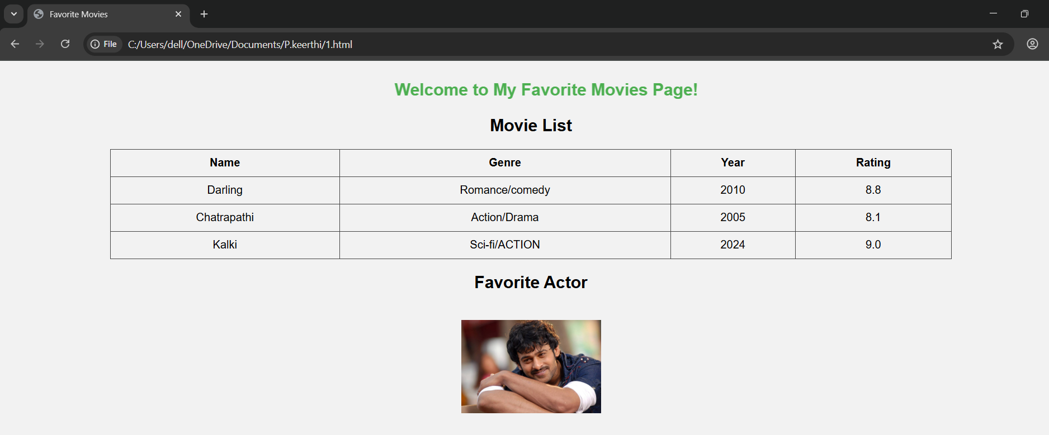

TASK 2: Design a webpage that includes a horizontal navigation menu with links to "Home," "About," "Services," and "Contact," followed by a section that displays a list of your favorite books in a neat table with columns for Title, Author, and Genre. Below the table, insert an image of the book cover for one of the books, a video review of the book, and an audio clip of an author interview.

Code:

<!DOCTYPE html>

<html>

<head>

<title>My Favorite Books</title>

<style>

        body {

            font-family: Arial, sans-serif;

        }

        nav {

            background-color: #333;

            overflow: hidden;

        }

        nav a {

            float: left;

            display: block;

            color: white;

            text-align: center;

            padding: 14px 20px;

            text-decoration: none;

        }

        nav a:hover {

            background-color: #575757;

        }

        table {

            width: 80%;

            margin: 20px auto;

            border-collapse: collapse;

        }

        table, th, td {

            border: 1px solid #999;

        }

        th, td {

            padding: 10px;

            text-align: left;

        }

        .media {

            width: 80%;

            margin: 20px auto;

            text-align: center;

        }

        img {

            width: 150px;

            height: auto;

        }

</style>

</head>

<body>

<!-- Navigation Menu -->

<nav>

<a href="#">Home</a>

<a href="#">About</a>

<a href="#">Services</a>

<a href="#">Contact</a>

</nav>

<!-- Table of Favorite Books -->

<table>

<tr>

<th>Title</th>

<th>Author</th>

<th>Genre</th>

</tr>

<tr>

            <td>Amma diaryloo konni pageeluu</td>

            <td>Ravi mantri</td>

            <td>Family drama</td>

        </tr>

        <tr>

            <td>Harry potter</td>

            <td>J.K rowling</td>

            <td>Fantasy</td>

        </tr>

        <tr>

            <td>Crime and Punishment</td>

            <td> Fyodor Dostoevsky</td>

            <td>psychological </td>

</tr>

</table>

<!-- Media Section -->

<div class="media">

<h3>Book Cover</h3>

<img src="https://www.chirukaanuka.com/cdn/shop/files/AmmaDiaryloKonniPageelu_1024x1024.jpg?v=1690615467" alt="Harry Potter Book Cover"><br>

<h3>Video Review</h3>

<video width="320" height="240" controls>

<source src="C:\Users\dell\Downloads\5752729-uhd_3840_2160_30fps.mp4" type="video/mp4">

            Your browser does not support the video tag.

</video>

<h3>Author Interview (Audio)</h3>

<audio controls>

<source src="https://www.w3schools.com/html/horse.mp3" type="audio/mpeg">

            Your browser does not support the audio element.

</audio>

</div>

</body>

</html>

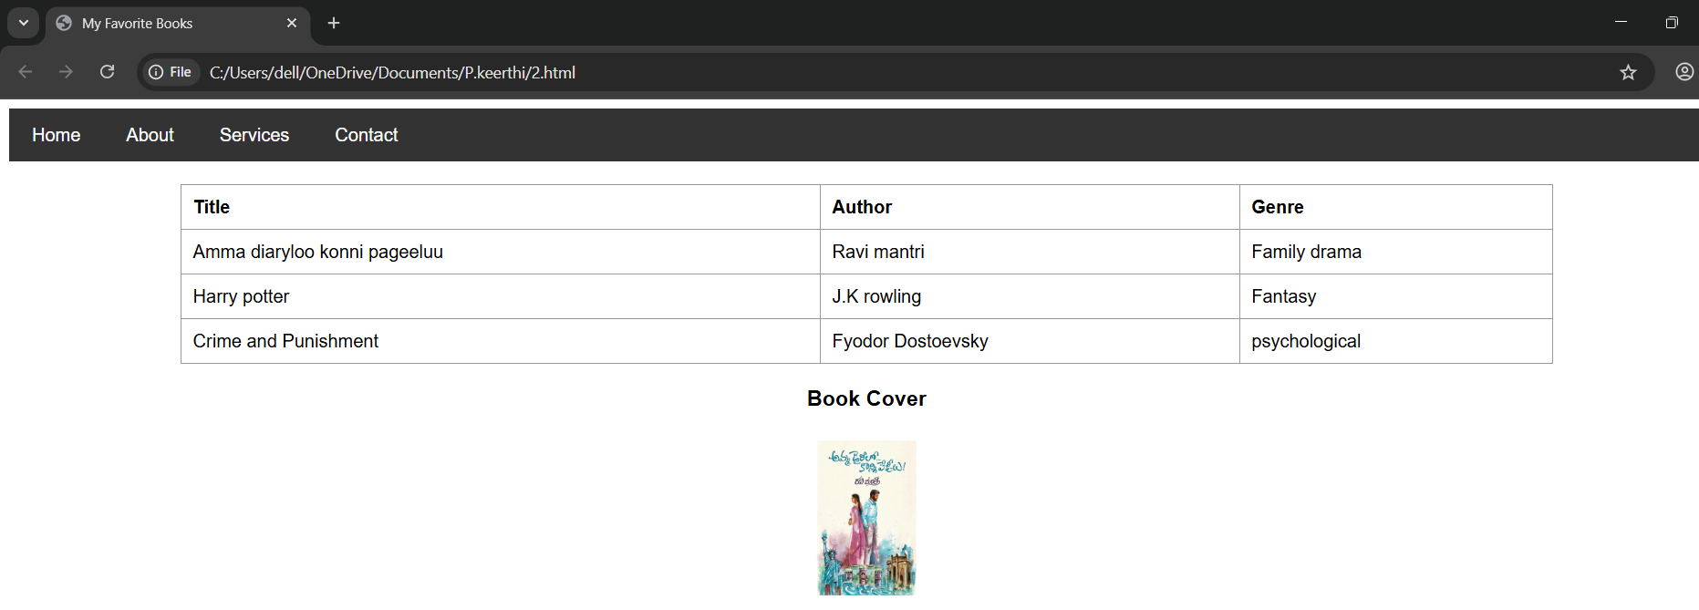

TASK 3: Create a portfolio webpage with a header that scrolls a welcome message across the screen, followed by a section that includes a table of your recent projects with columns for Project Name, Description, and Date. Below the table, add an image of a screenshot from one of the projects, a video tutorial on the project, and an audio description of the project.

Code:

<!DOCTYPE html>

<html lang="="en">

<head>

    <meta charset="UTF-8">

    <title>Portfolio Webpage</title>

    <style>

        body {

            font-family: Arial, sans-serif;

            margin: 20px;

        }

        table {

            width: 100%;

            border-collapse: collapse;

            margin-top: 20px;

        }

        table, th, td {

            border: 1px solid black;

            padding: 10px;

        }

        th {

            background-color: #f2f2f2;

        }

        img, iframe, audio {

            margin-top: 20px;

            width: 100%;

            max-width: 600px;

        }

    </style>

</head>

<body>

    <!-- Scrolling header -->

    <marquee behavior="scroll" direction="left" scrollamount="6">

        Welcome to My Portfolio!

    </marquee>

    <!-- Projects Table -->

    <h2>My Recent Projects</h2>

    <table>

        <tr>

            <th>Project Name</th>

            <th>Description</th>

            <th>Date</th>

        </tr>

        <tr>

            <td>Weather App</td>

            <td>Displays live weather using API</td>

            <td>June 2025</td>

        </tr>

        <tr>

            <td>Portfolio Site</td>

            <td>Personal portfolio website</td>

            <td>May 2025</td>

        </tr>

    </table>

    <!-- Screenshot of a project -->

    <h3>Project Screenshot</h3>

    <img src="https://play-lh.googleusercontent.com/cweCpoG0q7Z4qVBdozGoM1DFhp2U_kHmmbo2F1_qgF6BP-hCRai6uB9U1j28ZhaaYXU" alt="Project Screenshot">

<!-- Embedded YouTube Video -->

  <h3>Project Demo Video</h3>

    <iframe width="560" height="315" src="https://www.youtube.com/embed/MIYQR-Ybrn4?si=HERox0DadMF591l6" title="YouTube video player" frameborder="0" allow="accelerometer; autoplay; clipboard-write; encrypted-media; gyroscope; picture-in-picture; web-share" referrerpolicy="strict-origin-when-cross-origin" allowfullscreen></iframe>

    <!-- Audio Sample -->

    <h3>Audio Sample</h3>

    <audio controls>

        <source src="https://www.orangefreesounds.com/wp-content/uploads/2014/09/Rain-sound.mp3" type="audio/mpeg">

        Your browser does not support the audio element.

    </audio>

</body>

</html>

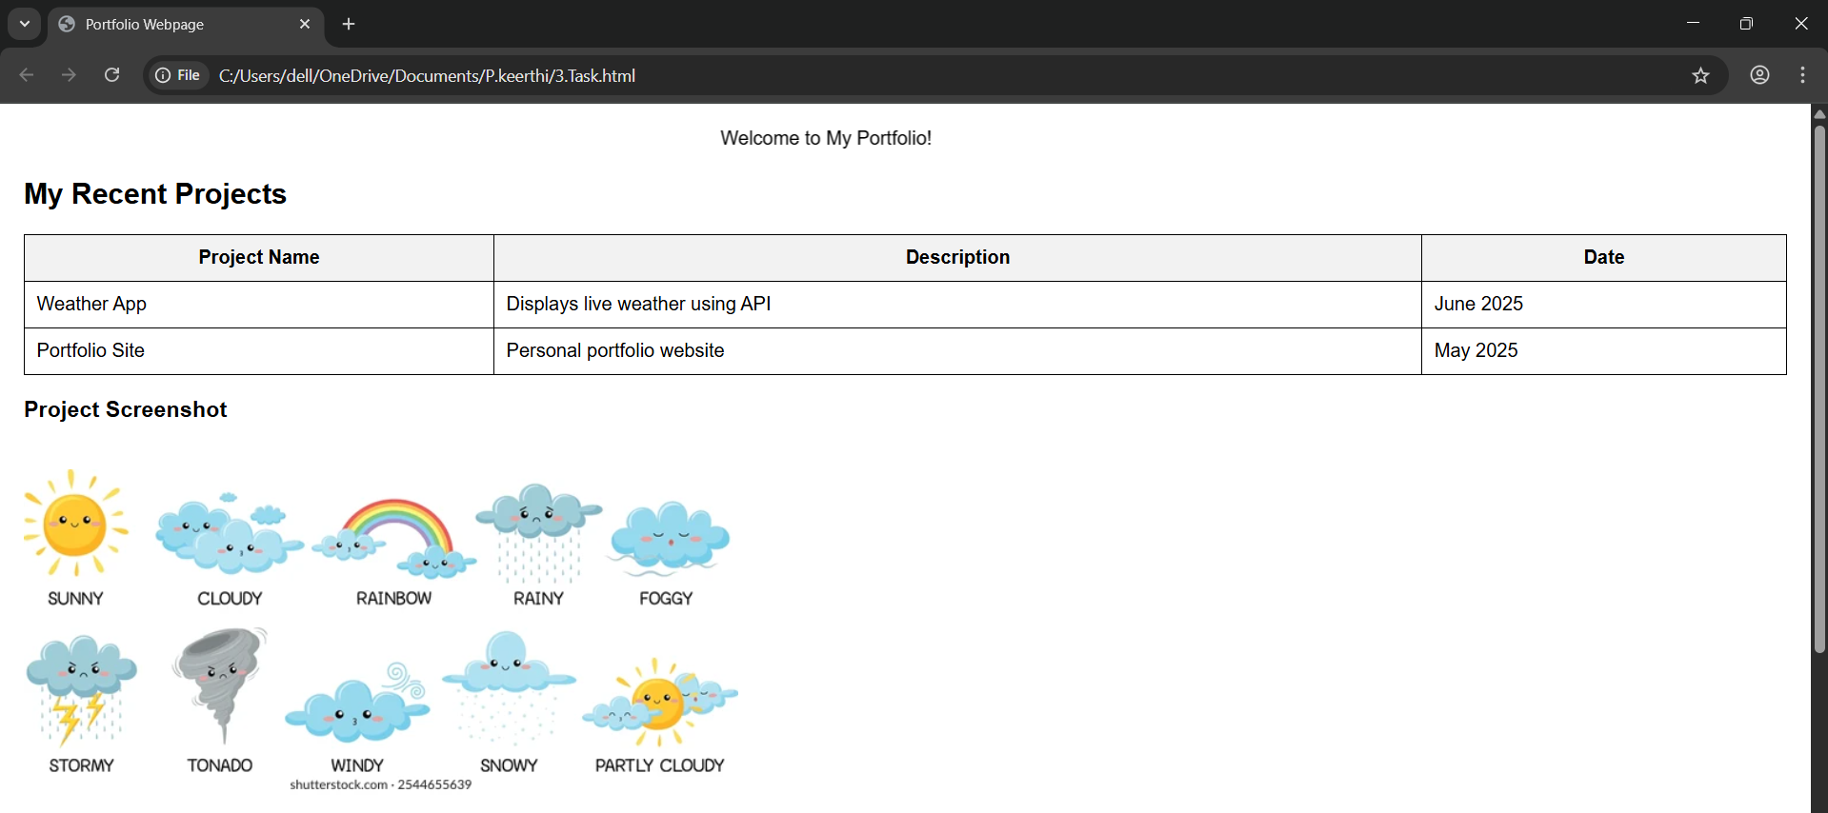

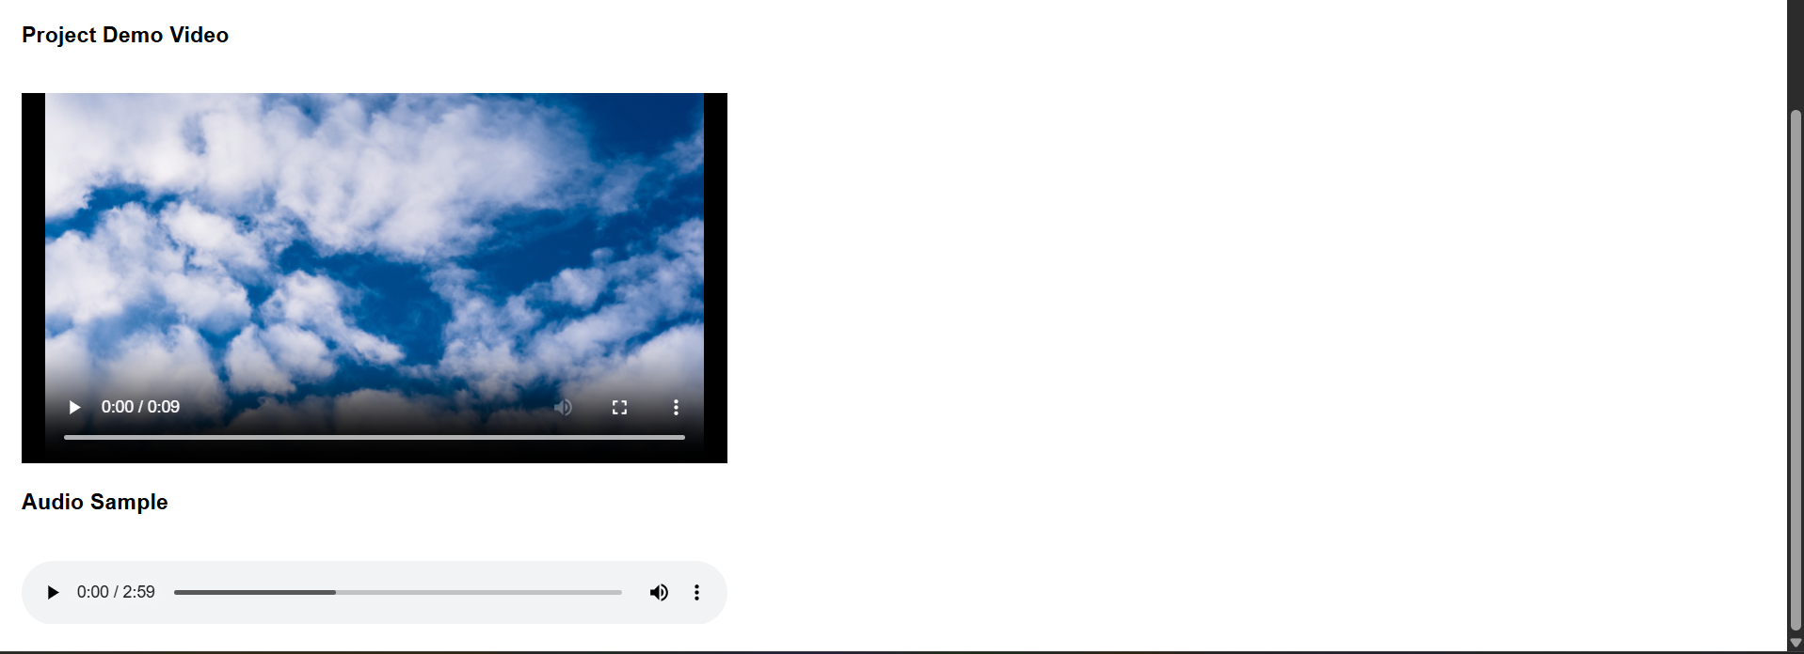

TASK 4:Create a basic HTML page introducing yourself. Design a webpage using appropriate HTML tags that displays:

• Your full name as a heading

• A short paragraph describing yourself

• A list of your hobbies using an unordered list

Code:

<!DOCTYPE html>

<html lang="en">

<head>

<meta charset="UTF-8">

<title>About Me</title>

</head>

<body>

<h1>Keerthi penmetsa</h1>

<p>

Hello! My name is keerthi penmetsa. I am a passionate learner who enjoys exploring web development and new technologies. I love working on creative projects that help me grow both personally and professionally.

</p>

<h2>My Hobbies</h2>

<ul>

<li>Reading Novels</li>

<li>Playing games</li>

<li>Listening to music</li>

<li>Coding and designing websites</li>

</ul>

</body>

</html>

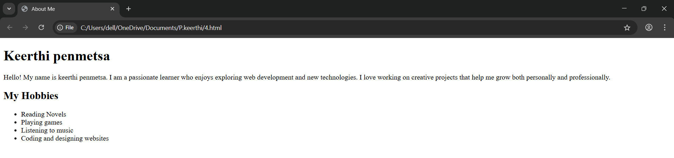

TASK 5:

Create a simple resume web page using HTML. The resume should include:

• Your name in a **tag**

**• A bio/summary using the tag**

**• A list of your skills using an unordered list**

**• A list of your qualifications using an ordered list**

**Code:**

<!DOCTYPE html>

<html>

<head>

<title>My Resume</title>

</head>

<body>

<!-- Name in a heading tag -->

<h1>Keerthi</h1>

<!-- Bio/summary using the paragraph tag -->

<p>I am a passionate web developer with a keen interest in creating user-friendly and responsive web applications. I enjoy learning new technologies and continuously improving my skills.</p>

<!-- Skills using an unordered list -->

<h2>Skills</h2>

<ul>

<li>HTML & CSS</li>

<li>JavaScript</li>

<li>Python</li>

<li>React.js</li>

<li>Git & GitHub</li>

</ul>

<!-- Qualifications using an ordered list -->

<h2>Qualifications</h2>

<ol>

<li>Bachelor of Technology in Computer Science</li>

<li>Full Stack Web Development Certification</li>

<li>Advanced JavaScript Course</li>

</ol>

</body>

</html>

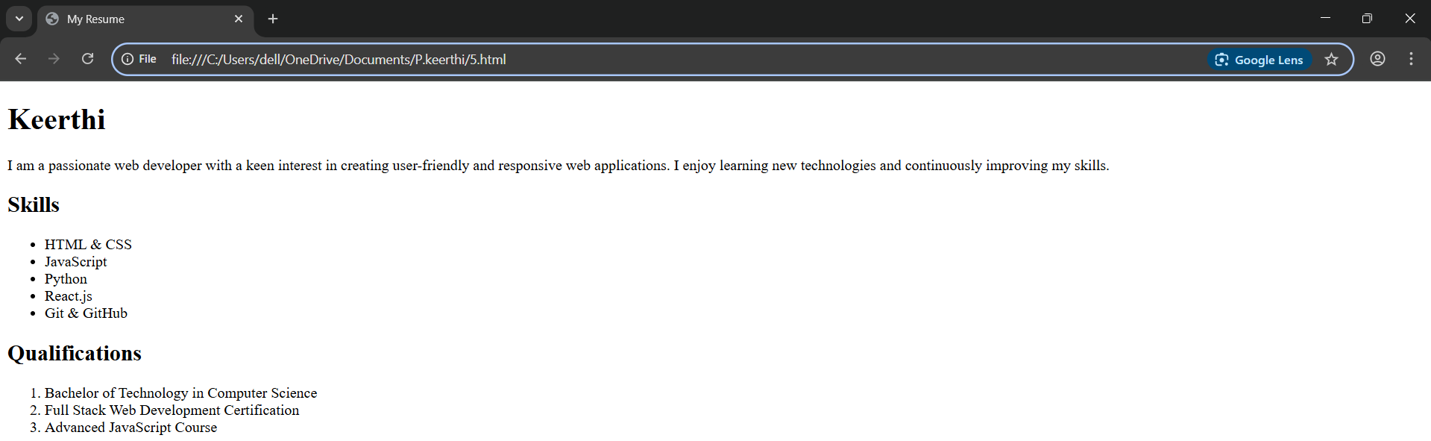

TASK 6:Create a paragraph demonstrating the following text formatting tags: Use the following tags in a single paragraph and observe their effect on text appearance: <br>,<strong>,<i>,<em>,<u>,<mark>,<small>

Code:

<!DOCTYPE html>

<html lang="en">

<head>

<meta charset="UTF-8">

<title>Text Formatting Example</title>

</head>

<body>

<p>

This is a <strong>strong</strong> word, and this is in <i>italic</i>.

<br>

We can also use <em>emphasis</em> to highlight words slightly differently.

<u>This text is underlined</u> to show importance.

Here's a <mark>highlighted section</mark> for extra focus.

And here is some <small>smaller text</small> for footnotes or side notes.

</p>

</body>

</html>

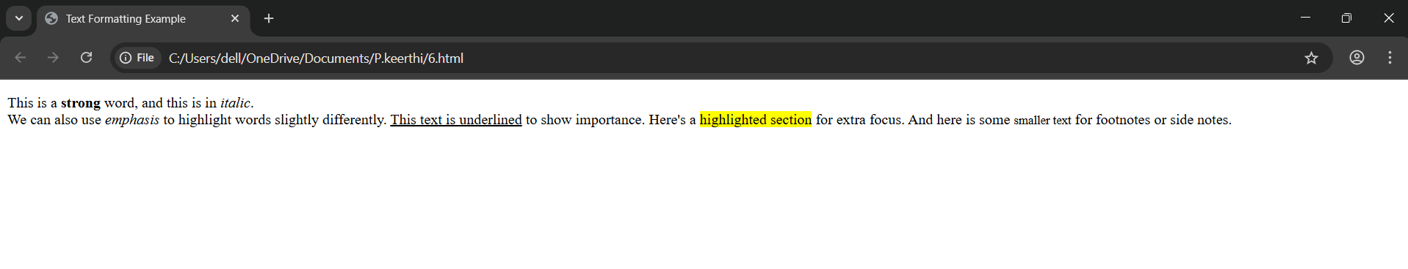

TASK 7:

Create a nested list of a shopping category.

• The main list should have categories like Fruits, Vegetables, Electronics.

• Each category should include 3 relevant items using nested lists.

Code:

<!DOCTYPE html>

<html>

<head>

    <title>Shopping List</title>

</head>

<body>

    <h1>Shopping List</h1>

    <ul>

        <li>Fruits

            <ul>

                <li>Blueberry</li>

                <li>pineappale</li>

                <li>mangoo</li>

            </ul>

        </li>

        <li>Vegetables

            <ul>

                <li>potato</li>

                <li>chilly</li>

                <li>carrot</li>

            </ul>

        </li>

        <li>Electronic<ul>

                <li>watch</li>

                <li>Tv</li>

<li>Headphones</li>

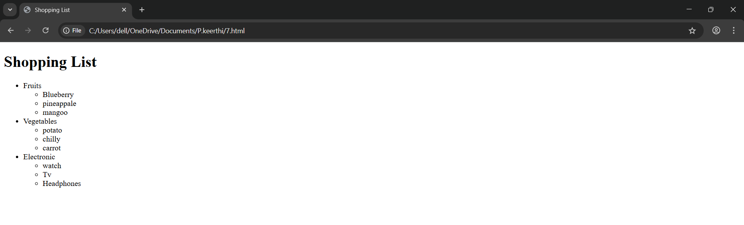

TASK 8:

Create an ordered list of your semester subjects.

• Use roman numerals for list markers

• Start the numbering from IV using the start attribute

Code:

<!DOCTYPE html>

<html>

<head>

<title>Semester Subjects</title>

</head>

<body>

<h1>My Semester Subjects</h1>

<ol type="I" start="4">

<li>foundation of data science</li>

        <li>Statistics/Mathematices</li>

        <li>Python</li>

        <li>Web interface desiging technologies</li>

        <li>data analytics methods

</ol>

</body>

</html>

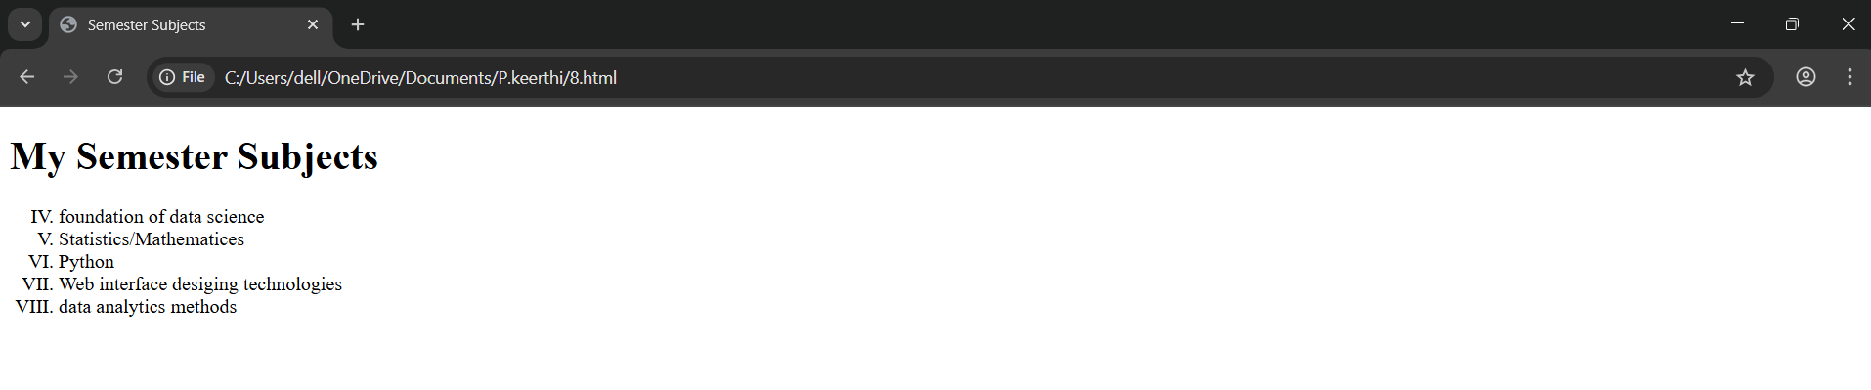

TASK 9 :

Create a student marks table using HTML table tags.

• Your table should contain the following columns

• Name, Subject, Marks, Grade

• Use for headers and for table data.

Code:

<!DOCTYPE html>

<html>

<head>

<title>Student Marks Table</title>

<style>

table {

border-collapse: collapse;

width: 60%;

margin: 20px;

}

th, td {

border: 1px solid #000;

padding: 8px 12px;

text-align: center;

}

th {

background-color: #f2f2f2;

}

</style>

</head>

<body>

<h1>Student Marks Table</h1>

<table>

<tr>

<th>Name</th>

<th>Subject</th>

<th>Marks</th>

<th>Grade</th>

</tr>

<tr>

<td>Rupa</td>

<td>Mathematics</td>

<td>95</td>

<td>A+</td>

</tr>

<tr>

<td>Aravindha</td>

<td>Science</td>

<td>80</td>

<td>B</td>

</tr>

<tr>

<td>Saniyaa</td>

<td>English</td>

<td>92</td>

<td>A</td>

</tr>

<tr>

<td>Supuu</td>

<td>History</td>

<td>88</td>

<td>B+</td>

</tr>

</table>

</body>

</html>

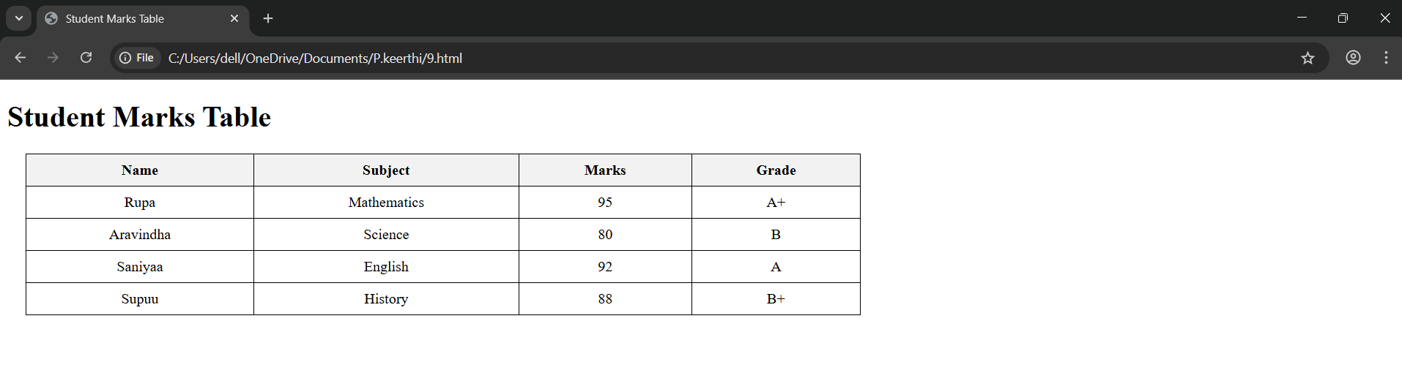

TASK 10:

Create a webpage that displays two images using the **Error! Filename not specified.** tag.

• One image should be sized to 300x300px

• The other image should be 500x400px

• Include the alt attribute to show alternate text if the image doesn't load

CODE:

<!DOCTYPE html>

<html>

<head>

    <title>Image Display Page</title>

</head>

<body>

    <h1>Displaying Images</h1>

    <!-- First image: 300x300 pixels -->

    <imgsrc=<https://blogger.googleusercontent.com/img/b/R29vZ2xl/AVvXsEhW7k7_O1IVntwszzaLTEOxN-xn2tuUz2-7HI_6Rrvo__NlYramAb4NmPjCt0FN4nz1-MbaSTdl9sPRiEfX4Pz1RqbHO0ISF-U2ean45u_U1y3mhy4Q3vxH2gcDwcO14_YDiiSz_Ycbj90e/s1600/cute-baby-panda-on-tree.jpg>>

    <br></br>

    <!-- Second image: 500x300 pixels -->

    <img src="https://r1.ilikewallpaper.net/iphone-wallpapers/download/25716/Cute-Lovely-Staring-Kitten-Cat-iphone-wallpaper-ilikewallpaper_com.jpg" alt="500x400 image - Example or placeholder image" width="500" height="400">

</body>

</html>

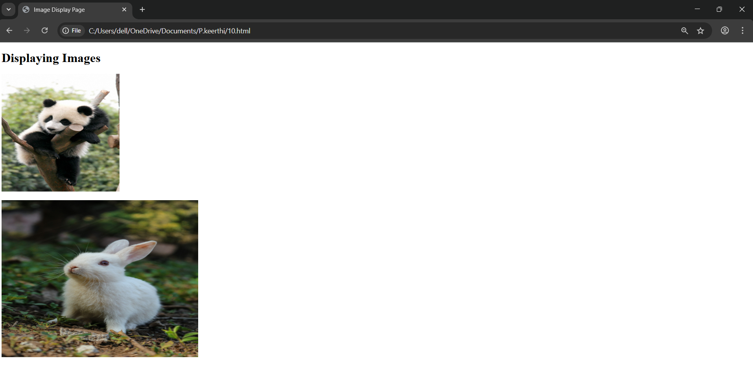

TASK 11:

Create a multimedia demo page using HTML.

• Embed a video using the tag with controls, height, and width attributes

• Embed an audio file using the tag with the controls attribute

Code:

<!DOCTYPE html>

<html lang="en">

<head>

<meta charset="UTF-8">

<title>Multimedia Demo Page</title>

</head>

<body>

<h1>Multimedia Demo</h1>

<!-- Embedded Video -->

<h2>Sample Video</h2>

<video width="640" height="360" controls>

<source src="sample-video.mp4" type="video/mp4">

Your browser does not support the video tag.

</video>

<!-- Embedded Audio -->

<h2>Sample Audio</h2>

<audio controls>

<source src="https://www.soundhelix.com/examples/mp3/SoundHelix-Song-1.mp3" type="audio/mpeg">

Your browser does not support the audio element.

</audio>

</body>

</html>

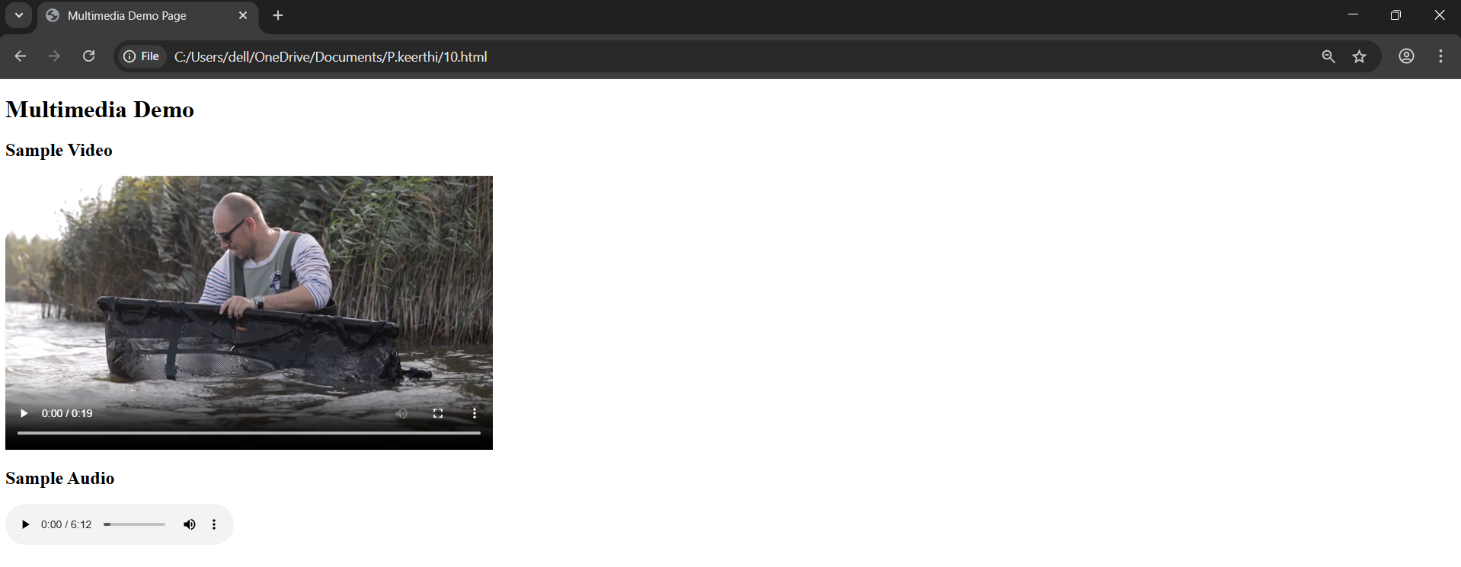

TASK 12:

Create a styled section using the tag.The should contain:

• A heading titled "Notification"

• A paragraph with any custom message

• Add a border and padding using inline styles

Code:

<!DOCTYPE html>

<html lang="en">

<head>

<meta charset="UTF-8">

<title>Styled Notification</title>

</head>

<body>

<div style="border: 2px solid #4CAF50; padding: 15px; background-color: #f9f9f9;">

<h2>Notification</h2>

<p>Your account settings have been updated successfully. Please review your preferences to ensure everything is correct.</p>

</div>

</body>

</html>

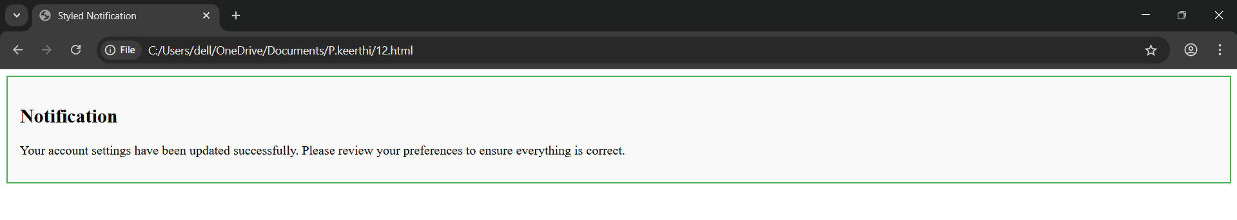

TASK 13:

Create a scrolling marquee using the tag.

• Add a scrolling text message from left to right

• Add a marquee with an image scrolling vertically (either up or down)

Code:

<!DOCTYPE html>

<html lang="en">

<head>

<meta charset="UTF-8">

<title>Scrolling Marquee Demo</title>

</head>

<body>

<!-- Marquee with scrolling text (left to right) -->

<marquee direction="right" behavior="scroll" scrollamount="5">

Welcome to our website! Stay tuned for updates.

</marquee>

<br><br>

<!-- Marquee with scrolling image (scrolling up) -->

<marquee direction="up" behavior="scroll" scrollamount="3" height="200px">

<img src=<https://static.vecteezy.com/system/resources/thumbnails/049/855/347/small_2x/nature-background-high-resolution-wallpaper-for-a-serene-and-stunning-view-photo.jpg>>

  </marquee>

</body>

</html>

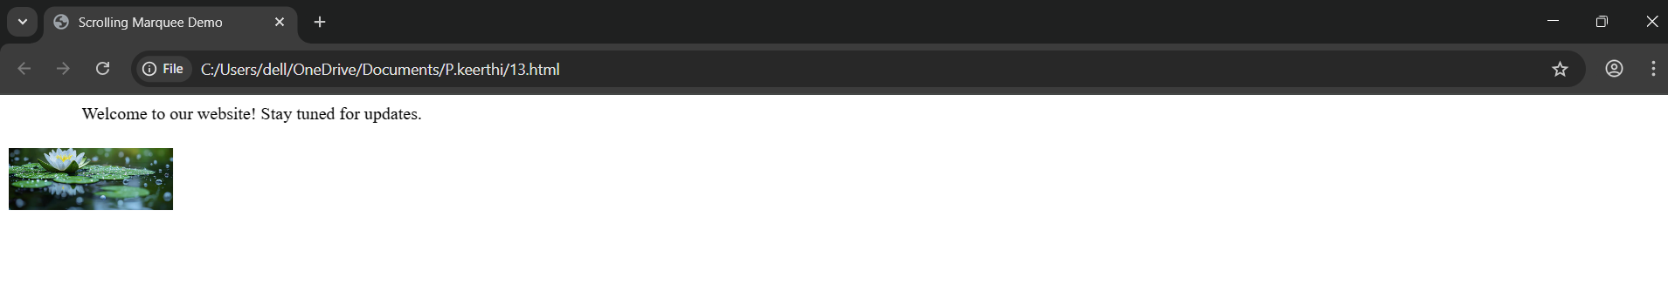

TASK 14:

Create a web page with a background image.

• Use the background attribute in the tag

• Add a short paragraph over the background image describing

It

Code:

<!DOCTYPE html>

<html lang="en">

<head>

    <meta charset="UTF-8">

    <title>Background Image Page</title>

</head>

<body background=<https://static.vecteezy.com/system/resources/thumbnails/049/855/347/small_2x/nature-background-high-resolution-wallpaper-for-a-serene-and-stunning-view-photo.jpg>>

    <p style="color: rgb(226, 230, 227); font-size: 18px; padding: 20px;">

        This serene background image captures the beauty of nature, bringing a sense of calm and inspiration to the page.

    </p>

</body>

</html>

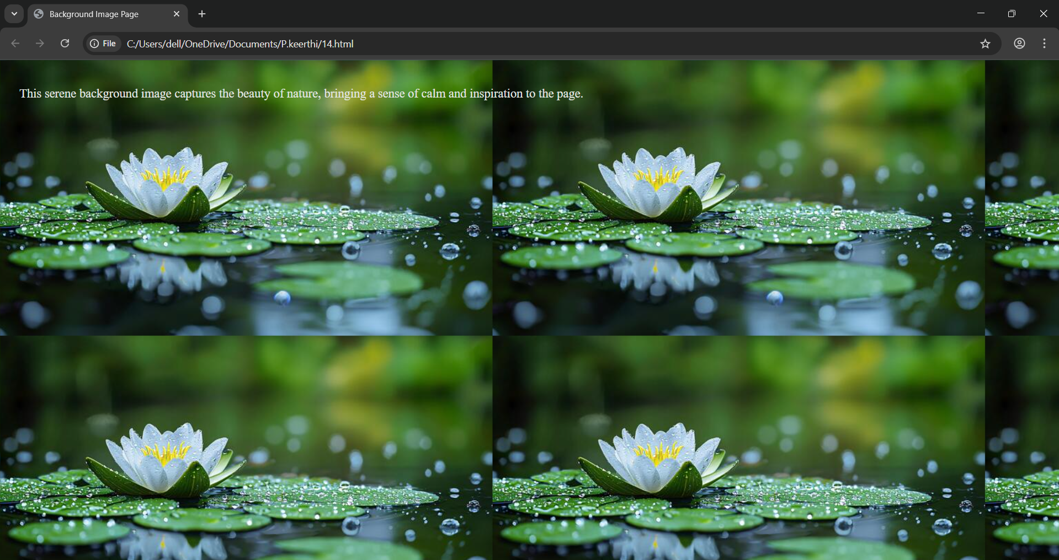

TASK 15:

Create a Student Registration Form Design a simple registration form with the following fields:

• Full Name (Text Input)

• Email (Text Input)

• Gender (Radio Buttons: Male, Female, Other)

• Courses Interested (Checkboxes: C, Java, Python, HTML)

• Location (Dropdown: Hyderabad, Vizag, Vijayawada)

• About Yourself (Textarea)

• A link at the bottom that says: “Already registered? Click here to login” (Use anchor tag)

Code:

<!DOCTYPE html>

<html lang="en">

<head>

    <meta charset="UTF-8">

    <title>Student Registration Form</title>

</head>

<body>

    <h2>Student Registration Form</h2>

    <form action="#" method="post"

        <!-- Full Name -->

        <label for="fullname">Full Name:</label>

        <input type="text" id="fullname" name="fullname" required>

        <br><br>

        <!-- Email -->

        <label for="email">Email:</label>

        <input type="email" id="email" name="email" required>

        <br><br>

        <!-- Gender -->

        <label>Gender:</label>

        <input type="radio" id="male" name="gender" value="Male">

        <label for="male">Male</label>

        <input type="radio" id="female" name="gender" value="Female">

        <label for="female">Female</label

        <input type="radio" id="other" name="gender" value="Other">

        <label for="other">Other</label>

        <br><br>

       <!-- Courses Interested -->

        <label>Courses Interested:</label><br>

        <input type="checkbox" id="c" name="courses" value="C">

        <label for="c">C</label><br>

        <input type="checkbox" id="java" name="courses" value="Java">

        <label for="java">Java</label><br>

        <input type="checkbox" id="python" name="courses" value="Python">

        <label for="python">Python</label><br>

        <input type="checkbox" id="html" name="courses" value="HTML">

        <label for="html">HTML</label><br><br>

        <!-- Location -->

        <label for="location">Location:</label>

        <select id="location" name="location">

            <option value="goa">goa</option>

            <option value="mumbai">mumbai</option>

            <option value="odisa">odisa</option>

        </select>

        <br><br>

        <!-- About Yourself -->

        <label for="about">About Yourself:</label><br>

        <textarea id="about" name="about" rows="4" cols="40"></textarea>

        <br><br>

        <!-- Submit Button -->

        <input type="submit" value="Register"

    </form>

    <p>Already registered? <a href="login.html">Click here to login</a></p>

</body>

</html>

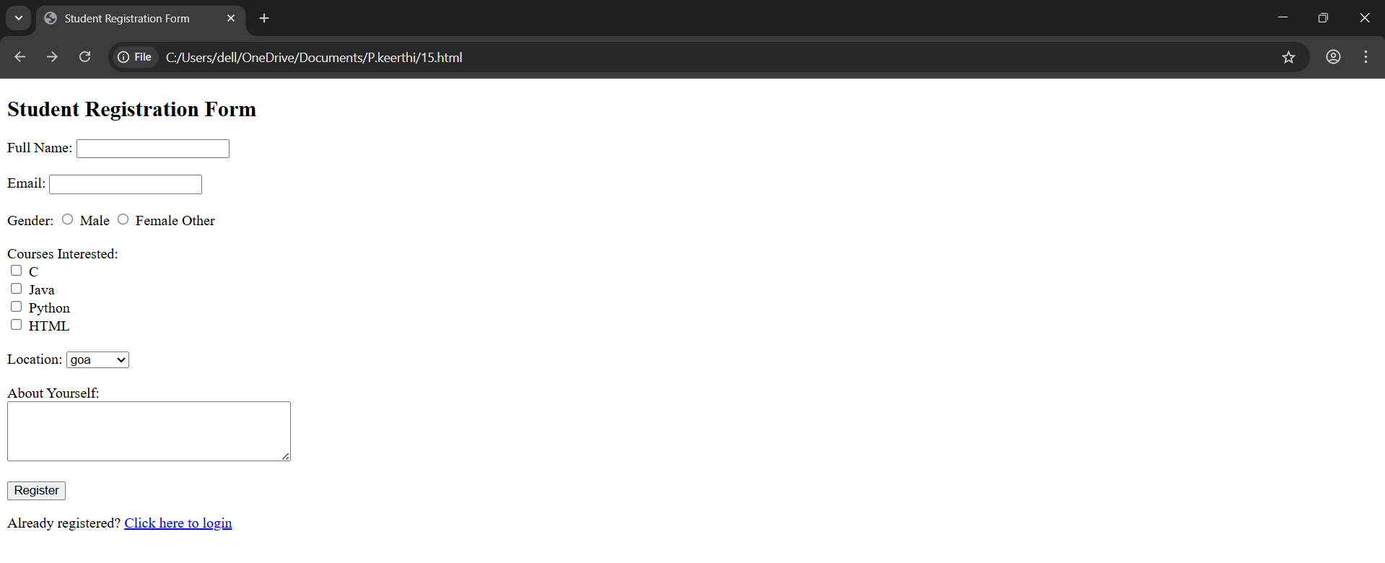

TASK 16:

Online Course Enrollment Page Instructions: Create an online course enrollment page

• Title of the page should be centered and prominent

• Add an introductory paragraph

• Include an image related to online learning

• Form inputs: o Student Name o Age o Select your course (at least 4 options)

• Choose your learning mode (Online, Offline, Hybrid)

• Checkbox for: “I agree to the terms and conditions”

• Include a text area for additional comments

Code:

<!DOCTYPE html>

<html lang="en">

<head>

<meta charset="UTF-8">

<title>Online Course Enrollment</title>

</head>

<body>

<!-- Page Title -->

<h1 style="text-align: center; font-size: 32px; color: #2c3e50;">Online Course Enrollment</h1>

<!-- Introductory Paragraph -->

<p style="text-align: center; max-width: 600px; margin: auto;">

Welcome to our online course enrollment page. Please fill out the form below to register for one of our exciting and career-boosting programs. Whether you prefer to study online, offline, or a mix of both, we have flexible learning options just for you!

</p>

<!-- Image related to online learning -->

<div style="text-align: center; margin: 20px;">

<img src="https://www.class.com/wp-content/uploads/2024/07/how-colleges-universities-increase-enrollment-with-synchronous-online-programs-blog-thumbnail.jpg" alt="Online Learning" width="200">

</div>

<!-- Enrollment Form -->

<form action="#" method="post" style="max-width: 500px; margin: auto;">

<!-- Student Name -->

<label for="name">Student Name:</label><br>

<input type="text" id="name" name="name" required><br><br>

<!-- Age -->

<label for="age">Age:</label><br>

<input type="number" id="age" name="age" required><br><br

<!-- Select your course -->

<label for="course">Select Your Course:</label><br>

<select id="course" name="course" required>

<option value="">-- Choose a Course --</option>

<option value="Web Development">Web Development</option>

<option value="Data Science">Data Science</option>

<option value="Machine Learning">Machine Learning</option>

<option value="UI/UX Design">UI/UX Design</option>

</select><br><br>

<!-- Learning Mode -->

<label>Choose Your Learning Mode:</label><br>

<input type="radio" id="online" name="mode" value="Online" required>

<label for="online">Online</label><br>

<input type="radio" id="offline" name="mode" value="Offline">

<label for="offline">Offline</label><br>

<input type="radio" id="hybrid" name="mode" value="Hybrid">

<label for="hybrid">Hybrid</label><br><br>

<!-- Terms and Conditions -->

<input type="checkbox" id="terms" name="terms" required>

<label for="terms">I agree to the terms and conditions</label><br><br>

<!-- Additional Comments -->

<label for="comments">Additional Comments:</label><br>

<textarea id="comments" name="comments" rows="4" cols="40"></textarea><br><br>

<!-- Submit Button -->

<input type="submit" value="Enroll Now">

</form>

</body>

</html>

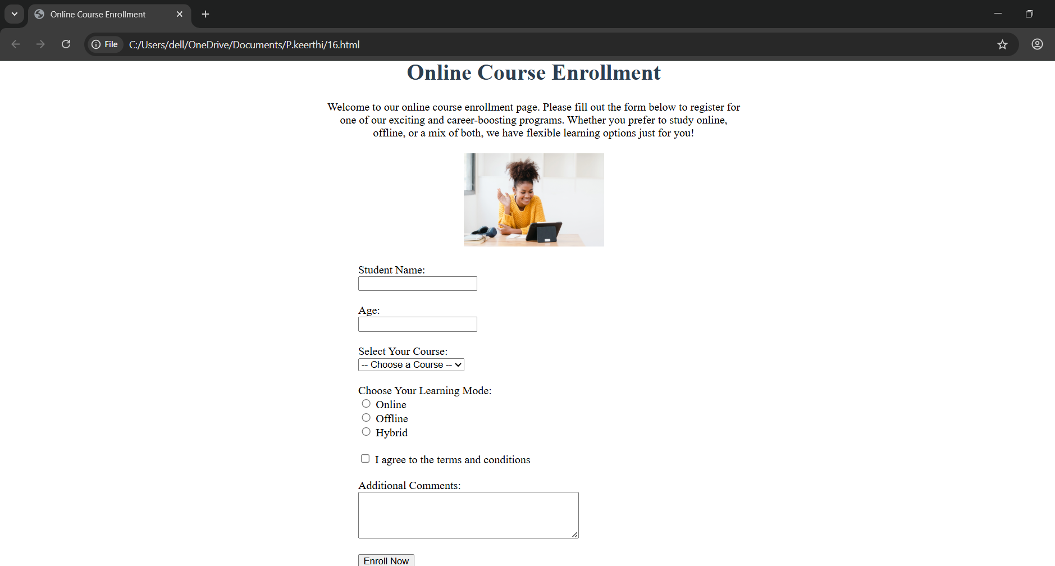

TASK 17:

Feedback Form for a Website Instructions: Create a feedback form that asks users:

• Name • Email

• How did you hear about the website? (radio options: Google, Social Media, Friend, Others)

• What did you like the most? (checkboxes: UI Design, Speed, Content, Responsiveness)

• Rate us (dropdown with options from 1 to 5 stars)

• Leave a message or comment in a large text area

• Add a button to submit feedback

• Include a link that takes the user back to the homepage

Code:

<!DOCTYPE html>

<html lang="en">

<head>

<meta charset="UTF-8">

<title>Feedback Form</title>

<style>

body { font-family: Arial, sans-serif; background: #f4f4f4; display: flex; align-items: center; justify-content: center; height: 100vh; }

.feedback-form { background: #fff; padding: 20px; border-radius: 6px; width: 350px; box-shadow: 0 2px 8px rgba(0,0,0,0.1); }

h2 { margin-top: 0; }

label { display: block; margin: 10px 0 5px; font-weight: bold; }

input[type="text"], input[type="email"], select, textarea { width: 100%; padding: 8px; margin-bottom: 12px; border: 1px solid #ccc; border-radius: 4px; }

fieldset { border: 1px solid #ccc; border-radius: 4px; padding: 10px; margin-bottom: 12px; }

legend { padding: 0 5px; font-weight: bold; }

.star-rating { display: flex; flex-direction: row-reverse; justify-content: flex-end; }

.star-rating input { display: none; }

.star-rating label { font-size: 1.5rem; color: #ccc; cursor: pointer; }

.star-rating input:checked ~ label,

.star-rating label:hover, .star-rating label:hover ~ label { color: #f5b301; }

button { width: 100%; padding: 10px; background: #007bff; border: none; color: white; border-radius: 4px; cursor: pointer; font-size: 1rem; } button:hover { background: #0056b3; }

.back-link { text-align: center; margin-top: 12px; }

</style>

</head>

<body>

<form class="feedback-form" action="#" method="post">

<h2>Feedback Form</h2>

<label for="name">Name:</label>

<input type="text" id="name" name="name" required>

<label for="email">Email:</label>

<input type="email" id="email" name="email" required>

<fieldset>

<legend>How did you hear about us?</legend>

<label><input type="radio" name="referrer" value="Google" required> Google</label>

<label><input type="radio" name="referrer" value="Social Media"> Social Media</label>

<label><input type="radio" name="referrer" value="Friend"> Friend</label>

<label><input type="radio" name="referrer" value="Others"> Others</label>

</fieldset>

<fieldset>

<legend>What did you like the most?</legend>

<label><input type="checkbox" name="likes" value="UI Design"> UI Design</label>

<label><input type="checkbox" name="likes" value="Speed"> Speed</label>

<label><input type="checkbox" name="likes" value="Content"> Content</label>

<label><input type="checkbox" name="likes" value="Responsiveness"> Responsiveness</label>

</fieldset>

<label>Rate us:</label>

<div class="star-rating">

<input type="radio" id="star5" name="rating" value="5"><label for="star5">★</label>

<input type="radio" id="star4" name="rating" value="4"><label for="star4">★</label>

<input type="radio" id="star3" name="rating" value="3"><label for="star3">★</label>

<input type="radio" id="star2" name="rating" value="2"><label for="star2">★</label>

<input type="radio" id="star1" name="rating" value="1"><label for="star1">★</label>

</div>

<label for="comments">Leave a message:</label>

<textarea id="comments" name="comments" rows="4"></textarea>

<button type="submit">Submit Feedback</button>

<div class="back-link"><a href="/">← Back to homepage</a></div>

</form>

</body>

</html>

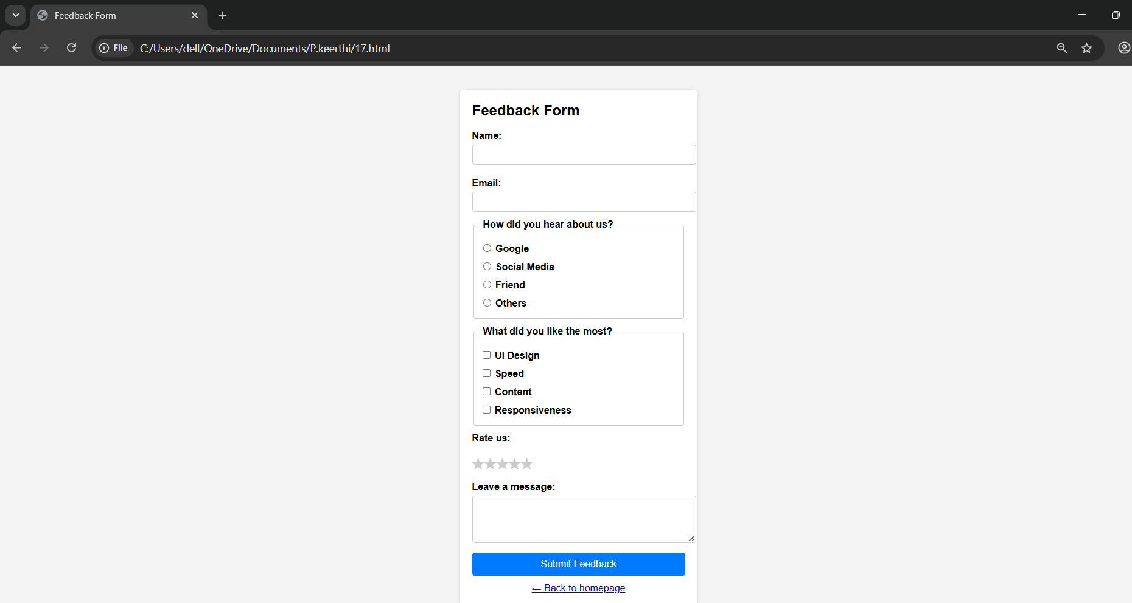

TASK 18:

College Event Signup Page Instructions: Design a form for a college tech fest:

• Title should scroll from right to left

• Include a short welcome message

• Embed a short video or audio about the event

• Provide a table listing different events and their timings

• Registration form should ask: o Name, Phone Number o Select your department o Select the events you want to participate in (at least 4 checkboxes) o Add a section to share any past experience (text area)

• Add a button to register • Include a link to view full event details (link to another page)

Code:

<!DOCTYPE html>

<html lang="en">

<head>

    <meta charset="UTF-8">

    <title>College Tech Fest Signup</title>

</head>

<body>

    <!-- Scrolling Title -->

    <marquee direction="left" scrollamount="6" style="font-size: 28px; color: navy;">

        Welcome to the Annual College Tech Fest – Register Now!

    </marquee>

    <!-- Welcome Message -->

    <p style="font-size: 16px; text-align: center;">

        Join us for an exciting celebration of innovation, creativity, and technology! Participate in events, showcase your talent, and win amazing prizes.

    </p>

    <!-- Embedded Video or Audio (choose one as needed) -->

    <div style="text-align: center;">

       <iframe width="560" height="315"

    src="https://www.youtube.com/embed/ZKbouOSlr7A?si=G3Zl8-M21DxfODTg"

    title="YouTube video player" frameborder="0"

    allow="accelerometer; autoplay; clipboard-write; encrypted-media; gyroscope; picture-in-picture; web-share"

    allowfullscreen>

</iframe>

        <!-- Or use audio instead -

        <audio controls>

    <source src="https://www.soundhelix.com/examples/mp3/SoundHelix-Song-1.mp3" type="audio/mpeg">

    Your browser does not support the audio element.

</audio>

    </div>

    <br>

    <!-- Event Schedule Table -->

    <h2>Event Schedule</h2>

    <table border="1" cellpadding="10" cellspacing="0">

        <tr>

            <th>Event</th>

            <th>Time</th>

        </tr>

        <tr>

            <td>Coding Hackathon</td>

            <td>10:00 AM - 12:00 PM</td>

        </tr>

        <tr>

            <td>Robotics Challenge</td>

            <td>12:30 PM - 2:00 PM</td>

        </tr>

        <tr>

            <td>Tech Quiz</td>

            <td>2:30 PM - 3:30 PM</td>

        </tr>

        <tr>

            <td>App Design Contest</td>

            <td>4:00 PM - 5:30 PM</td>

        </tr>

    </table>

    <br>

    <!-- Registration Form -->

    <h2>Event Registration Form</h2>

    <form action="#" method="post">

        <!-- Name -->

        <label for="name">Name:</label><br>

        <input type="text" id="name" name="name" required><br><br>

        <!-- Phone Number -->

        <label for="phone">Phone Number:</label><br>

        <input type="tel" id="phone" name="phone" required><br><br>

        <!-- Department -->

        <label for="department">Select Your Department:</label><br>

        <select id="department" name="department" required>

            <option value="">-- Choose Department --</option>

            <option value="CSE">Computer Science</option>

            <option value="ECE">Electronics</option>

            <option value="ME">Mechanical</option>

            <option value="EEE">Electrical</option>

        </select><br><br>

        <!-- Events Selection -->

        <label>Select Events You Want to Participate In:</label><br>

        <input type="checkbox" id="hackathon" name="events" value="Coding Hackathon">

        <label for="hackathon">Coding Hackathon</label><br>

        <input type="checkbox" id="robotics" name="events" value="Robotics Challenge">

        <label for="robotics">Robotics Challenge</label><br>

        <input type="checkbox" id="quiz" name="events" value="Tech Quiz">

        <label for="quiz">Tech Quiz</label><br>

        <input type="checkbox" id="design" name="events" value="App Design Contest">

        <label for="design">App Design Contest</label><br><br>

        <!-- Past Experience -->

        <label for="experience">Share Any Past Experience:</label><br>

        <textarea id="experience" name="experience" rows="4" cols="50" placeholder="Tell us about your experience..."></textarea><br><br>

        <!-- Register Button -->

        <input type="submit" value="Register Now">

    </form>

    <!-- Link to Event Details Page -->

    <p style="margin-top: 20px;">

        <a href="event-details.html">View Full Event Details</a>

    </p>

</body>

</html>

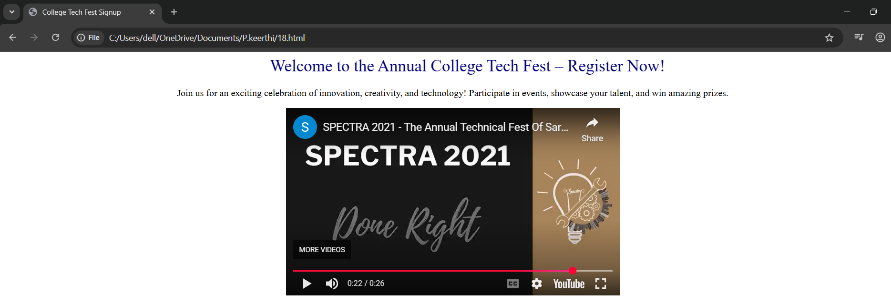

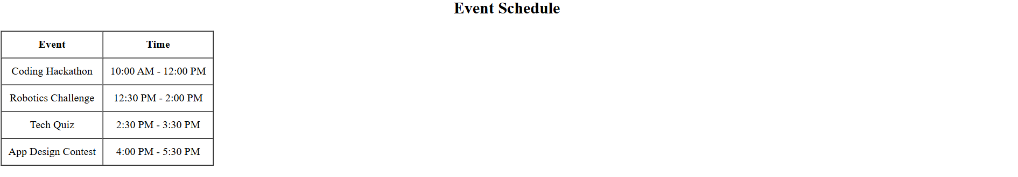



TASK 19:

Job Application Form Instructions: Design a job application form page:

• Use a heading to label the page

• Add a short paragraph describing the company

• Inputs required: o Applicant Name, Email ID o Choose preferred job role (Backend, Frontend, Full Stack) o Skills (checkboxes like HTML, CSS, Python, Java) o Upload Resume (use a label here for now) o Add a box where applicant writes about why they want this job

• Add a submission button • Provide a clickable link: “Visit our company page”

CODE:

<!DOCTYPE html>

<html lang="en">

<head>

<meta charset="UTF-8">

<title>Job Application Form</title>

<style>

body {

font-family: Arial, sans-serif;

background: #f2f3f5;

margin: 20px;

display: flex;

justify-content: center;

}

.container {

background: #fff;

padding: 25px 30px;

max-width: 600px;

width: 100%;

border-radius: 6px;

box-shadow: 0 2px 8px rgba(0,0,0,0.1);

}

h1 {

text-align: center;

margin-bottom: 15px;

color: #333;

}

p.description {

text-align: center;

margin-bottom: 20px;

color: #555;

}

.form-group {

margin-bottom: 15px;

}

.form-group label {

font-weight: bold;

display: block;

margin-bottom: 5px;

}

.form-group input[type="text"],

.form-group input[type="email"],

.form-group select,

.form-group textarea {

width: 100%;

padding: 8px;

border: 1px solid #ccc;

border-radius: 4px;

box-sizing: border-box;

}

.form-group textarea {

resize: vertical;

min-height: 100px;

}

.skills-group label {

display: inline-block;

margin-right: 10px;

}

.form-group input[type="file"] {

margin-top: 5px;

}

button {

background: #007bff;

color: white;

padding: 12px;

border: none;

border-radius: 4px;

cursor: pointer;

width: 100%;

font-size: 1rem;

}

button:hover {

background: #0056b3;

}

.footer-link {

text-align: center;

margin-top: 15px;

}

.footer-link a {

color: #007bff;

text-decoration: none;

}

.footer-link a:hover {

text-decoration: underline;

}

</style>

</head>

<body>

<div class="container">

<h1>Job Application Form</h1>

<p class="description">Join InnovateTech — we’re shaping the future of web & mobile innovation. Apply today!</p>

<form action="/submit-application" method="post" enctype="multipart/form-data">

<div class="form-group">

<label for="name">Applicant Name:</label>

<input type="text" id="name" name="name" required>

</div>

<div class="form-group">

<label for="email">Email ID:</label>

<input type="email" id="email" name="email" required>

</div>

<div class="form-group">

<label for="role">Preferred Job Role:</label>

<select id="role" name="role" required>

<option value="">Select a role</option>

<option value="backend">Backend</option>

<option value="frontend">Frontend</option>

<option value="fullstack">Full Stack</option>

</select>

</div>

<div class="form-group skills-group">

<label>Skills:</label>

<label><input type="checkbox" name="skills" value="HTML"> HTML</label>

<label><input type="checkbox" name="skills" value="CSS"> CSS</label>

<label><input type="checkbox" name="skills" value="Python"> Python</label>

<label><input type="checkbox" name="skills" value="Java"> Java</label>

</div>

<div class="form-group">

<label for="resume">Upload Resume:</label>

<input type="file" id="resume" name="resume" accept=".pdf,.doc,.docx" required>

</div>

<div class="form-group">

<label for="why">Why do you want this job?</label>

<textarea id="why" name="why" placeholder="Tell us about your motivation..." required></textarea>

</div>

<button type="submit">Submit Application</button>

</form>

<div class="footer-link">

<a href="https://innovate-tech.example.com" target="_blank">Visit our company page</a>

</div>

</div>

</body>

</html>

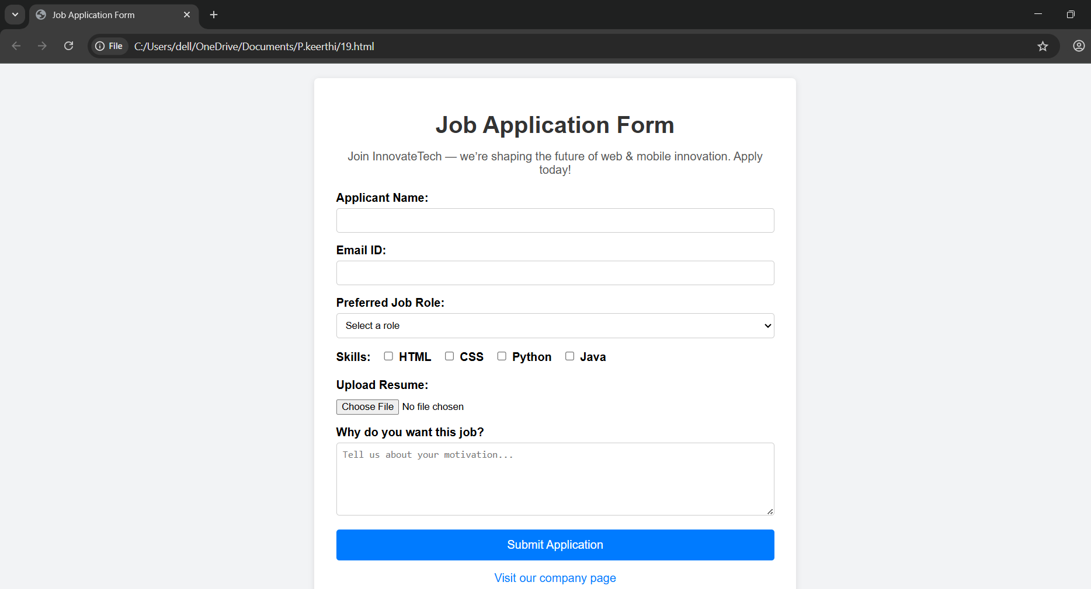

TASK 20:

Create a personal website homepage that includes:

• A top section with your name and links to different pages (like Home, Projects, and Contact).

• A short paragraph describing your background.

• An image of yourself with a short description below it.

Code:

<!DOCTYPE html>

<html lang="en">

<head>

<meta charset="UTF-8">

<title>My Personal Homepage</title>

</head>

<body>

<!-- Top Section: Name and Navigation -->

<header style="background-color: #f2f2f2; padding: 20px; text-align: center;">

<h1>Keerthi</h1>

<nav>

<a href="index.html">Home</a> |

<a href="projects.html">Projects</a> |

<a href="contact.html">Contact</a>

</nav>

</header>

<!-- About Section -->

<section style="padding: 20px; max-width: 800px; margin: auto;">

<h2>About Me</h2>

<p>

I’m a passionate web developer with a background in computer science and a love for creating dynamic, responsive websites.

I enjoy working with HTML, CSS, JavaScript, and Python to build user-friendly and efficient web applications.

</p>

</section>

<!-- Image and Description -->

<section style="padding: 20px; text-align: center;">

<img src= <https://encrypted-tbn0.gstatic.com/images?q=tbn:ANd9GcRCnIq8x0j7Q9WZ_BOSEixDd_dyko91SR-R9A&s>>

<p style="margin-top: 10px;">Hi! I'm J, and this is where I share my coding journey, projects, and ideas. Thanks for visiting!</p>

</section>

</body>

</html>

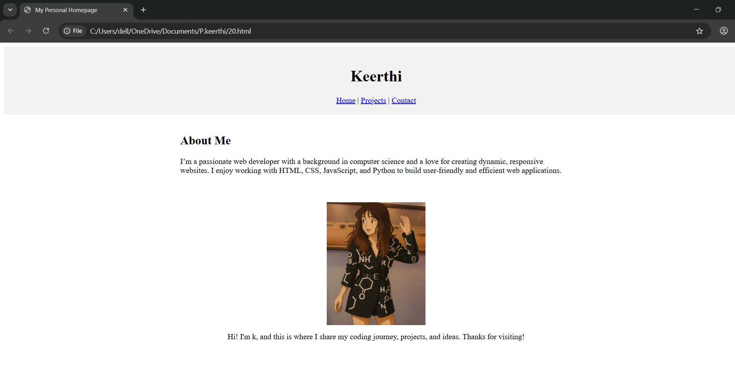

TASK 21:

Design a layout with two vertical panels:

• The left panel should show any website of your choice.

• The right panel should show Wikipedia

• Remove the divider between the two panels.

CODE:

<!DOCTYPE html>

<html lang="en">

<head>

<meta charset="UTF-8">

<title>Two Vertical Panels</title>

<style>

body, html {

margin: 0;

padding: 0;

height: 100%;

overflow: hidden;

}

.container {

display: flex;

height: 100vh;

width: 100vw;

}

.panel {

flex: 1;

border: none; /* Removes any visible divider */

}

</style>

</head>

<body>

<div class="container">

<!-- Left panel: Example website (can change URL if blocked) -->

<iframe class="panel" src="https://example.com"></iframe>

<!-- Right panel: Wikipedia -->

<iframe class="panel" src="https://en.wikipedia.org"></iframe>

</div>

</body>

</html>

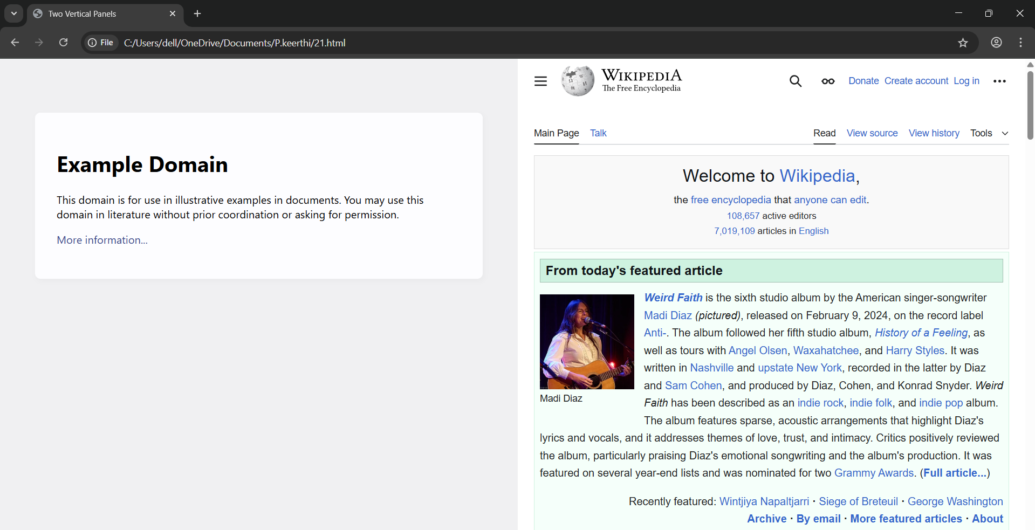

TASK 22:

Build a form for event registration where:

• Users can enter their full name, email, and phone number

• They can choose one gender option and select multiple interests (like music, sports, art).

• Users should be able to pick their city from a dropdown.

• A comments box should be available for extra details.

• Add buttons to submit, reset, and trigger a confirmation alert

Code:

<!DOCTYPE html>

<html lang="en">

<head>

    <meta charset="UTF-8">

    <title>Event Registration Form</title>

    <script>

        function showConfirmation() {

            alert("Thank you for registering! Your details have been noted.");

        }

    </script>

</head>

<body>

    <h1>Event Registration Form</h1>

    <form action="#" method="post">

        <!-- Full Name -->

        <label for="fullname">Full Name:</label><br>

        <input type="text" id="fullname" name="fullname" required><br><br>

        <!-- Email -->

        <label for="email">Email:</label><br>

        <input type="email" id="email" name="email" required><br><br>

        <!-- Phone Number -->

        <label for="phone">Phone Number:</label><br>

        <input type="tel" id="phone" name="phone" required><br><br>

        <!-- Gender -->

        <label>Gender:</label><br>

        <input type="radio" id="male" name="gender" value="Male">

        <label for="male">Male</label><br>

        <input type="radio" id="female" name="gender" value="Female">

        <label for="female">Female</label><br>

        <input type="radio" id="other" name="gender" value="Other">

        <label for="other">Other</label><br><br>

        <!-- Interests -->

        <label>Interests:</label><br>

        <input type="checkbox" id="music" name="interests" value="Music">

        <label for="music">Music</label><br>

        <input type="checkbox" id="sports" name="interests" value="Sports">

        <label for="sports">Sports</label><br>

        <input type="checkbox" id="art" name="interests" value="Art">

        <label for="art">Art</label><br><br>

        <!-- City -->

        <label for="city">Select Your City:</label><br>

        <select id="city" name="city" required>

            <option value="">-- Choose City --</option>

            <option value="New York">New York</option>

            <option value="Los Angeles">Los Angeles</option>

            <option value="Chicago">Chicago</option>

            <option value="Houston">Houston</option>

        </select><br><br>

        <!-- Comments -->

        <label for="comments">Additional Comments:</label><br>

        <textarea id="comments" name="comments" rows="4" cols="50" placeholder="Enter any extra details here..."></textarea><br><br>

        <!-- Buttons -->

        <input type="submit" value="Submit">

        <input type="reset" value="Reset">

        <input type="button" value="Confirm" onclick="showConfirmation()"

  </form>

</body>

</html>

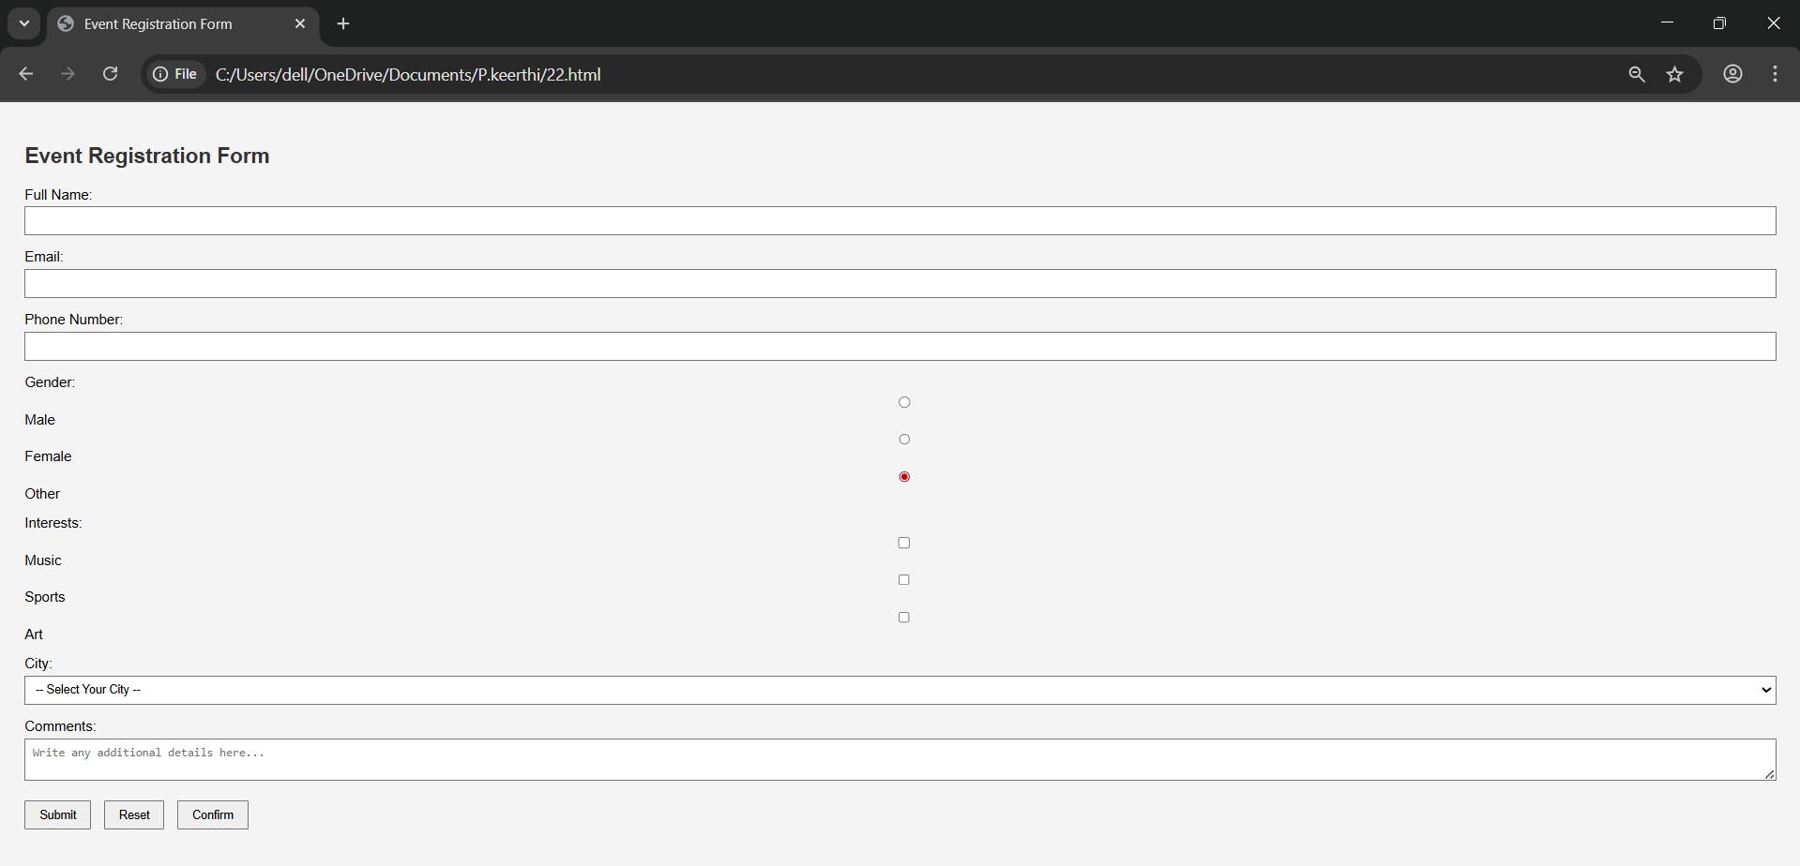

TASK 23:

Create a single webpage layout that includes:

• A section displaying today’s news headline and summary.

• Another section beside it displaying tips or advertisements.

• A bottom section with author info, the year, and an email to contact

Code:

<!DOCTYPE html>

<html lang="en">

<head>

  <meta charset="UTF-8">

  <title>News Page</title>

  <style>

    body {

      font-family: Arial, sans-serif;

      margin: 0;

      padding: 0;

      background-color: #f7f7f7;

    }

    .container {

      display: flex;

      padding: 20px;

      gap: 20px;

    }

    .news {

      flex: 2;

      background-color: #fff;

      padding: 20px;

      border-radius: 8px;

      box-shadow: 0 0 10px rgba(0,0,0,0.1);

    }

    .ads {

      flex: 1;

      background-color: #e6f3ff;

      padding: 20px;

      border-radius: 8px;

      box-shadow: 0 0 10px rgba(0,0,0,0.1);

    }

    footer {

      background-color: #333;

      color: white;

      padding: 15px;

      text-align: center;

      margin-top: 20px;

    }

    h2 {

      color: #333;

    }

  </style>

</head>

<body>

  <div class="container">

    <div class="news">

      <h2>Today's Headline</h2>

      <p><strong>Global Markets Rally as Tech Stocks Soar</strong></p>

      <p>Technology shares led a broad rally in global stock markets today as investors reacted to new innovations in AI and stronger-than-expected earnings reports.</p>

    </div>

    <div class="ads">

      <h2>Tips & Ads</h2>

      <ul>

        <li>💡 Productivity Tip: Start your day with 3 priorities.</li>

        <li>📢 Ad: 50% off on Smartwatches - Visit techdealz.com!</li>

        <li>🌱 Health Tip: Drink 2L of water daily for clear skin.</li>

      </ul>

    </div>

  </div>

  <footer>

    <p>Author: keerthi &nbsp; | &nbsp; © 2025 &nbsp; | &nbsp; Contact: <a href="mailto:keerthi@example.com" style="color:#aadfff;">keerthi@example.com</a></p>

  </footer>

</body>

</html>

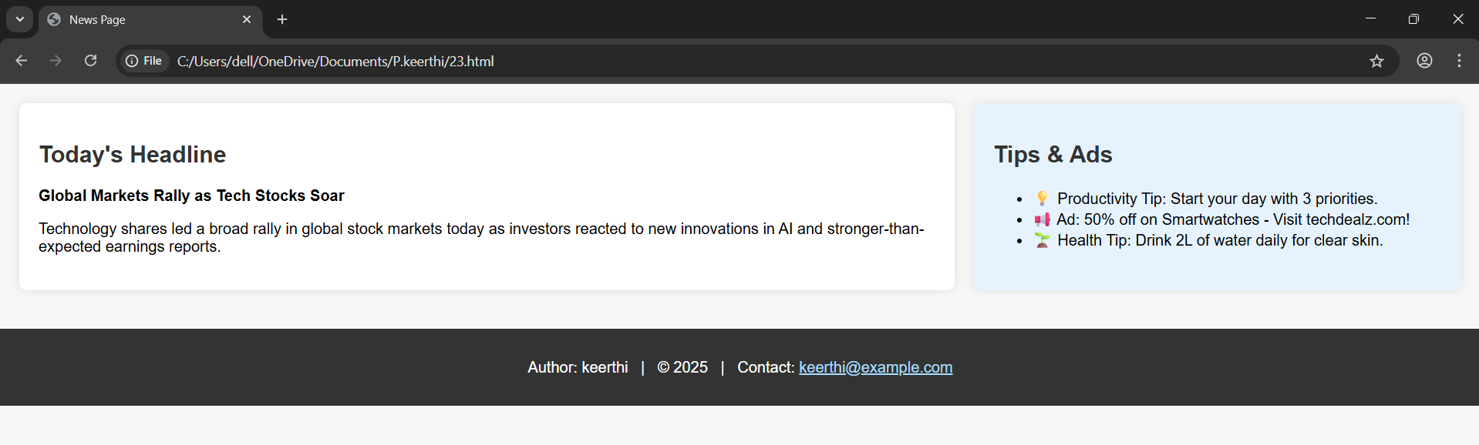

TASK 24:

Build a payment selection form that groups options like UPI, Credit Card, and Cash on delivery under the box.

• Add a label above this section describing it as a "Payment Method".

• Each option should be selectable by clicking a circle.

Code:

<!DOCTYPE html>

<html lang="en">

<head>

  <meta charset="UTF-8">

  <title>Payment Method Form</title>

  <style>

    body {

      font-family: Arial, sans-serif;

      padding: 30px;

      background-color: #f9f9f9;

    }

    .payment-box {

      background-color: #ffffff;

      padding: 20px;

      border: 2px solid #ccc;

      border-radius: 10px;

      max-width: 400px;

      margin: auto;

      box-shadow: 0 0 10px rgba(0,0,0,0.05);

    }

    .payment-box h2 {

      margin-bottom: 15px;

      color: #333;

    }

    .option {

      display: flex;

      align-items: center;

      margin-bottom: 10px;

      cursor: pointer;

    }

    .option input[type="radio"] {

      margin-right: 10px;

      accent-color: #007bff;

      transform: scale(1.2);

    }

    label {

      font-size: 16px;

      color: #333;

      cursor: pointer;

    }

  </style>

</head>

<body>

  <div class="payment-box">

    <h2>Payment Method</h2>

    <div class="option">

      <input type="radio" id="upi" name="payment" value="UPI">

      <label for="upi">UPI</label>

    </div>

    <div class="option">

      <input type="radio" id="card" name="payment" value="Credit Card">

      <label for="card">Credit Card</label>

    </div>

    <div class="option">

      <input type="radio" id="cod" name="payment" value="Cash on Delivery">

      <label for="cod">Cash on Delivery</label>

    </div>

  </div>

</body>

</html>

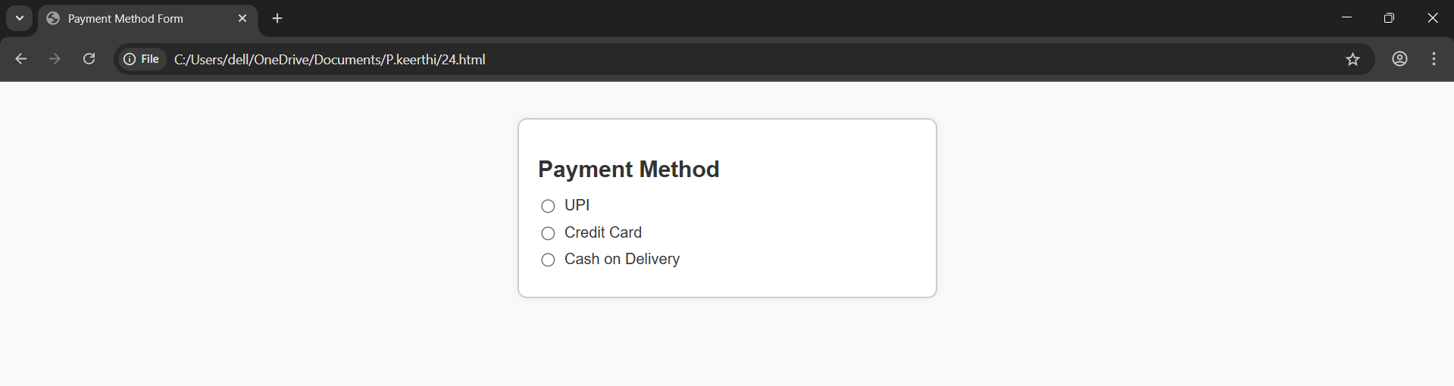

TASK 25:

Display a product offer where:

• The original price is shown with a line through it.

• The discounted price is highlighted.

• A note says that new features are included (highlighted with underlining).

Code:

<!DOCTYPE html>

<html lang="en">

<head>

  <meta charset="UTF-8">

  <title>Product Offer</title>

  <style>

    body {

      font-family: Arial, sans-serif;

      padding: 30px;

      background-color: #f4f4f4;

    }

    .offer-box {

      background-color: #fff;

      border: 2px solid #ccc;

      border-radius: 10px;

      padding: 20px;

      max-width: 400px;

      margin: auto;

      box-shadow: 0 0 10px rgba(0,0,0,0.1);

    }

    .product-name {

      font-size: 22px;

      font-weight: bold;

      margin-bottom: 10px;

      color: #333;

    }

    .price {

      font-size: 18px;

      margin-bottom: 10px;

    }

    .original-price {

      text-decoration: line-through;

      color: #888;

      margin-right: 10px;

    }

    .discounted-price {

      color: #d9534f;

      font-weight: bold;

      background-color: #ffe0e0;

      padding: 3px 8px;

      border-radius: 5px;

    }

    .features {

      margin-top: 15px;

      font-size: 16px;

    }

    .features u {

      color: #007bff;

    }

  </style>

</head>

<body>

  <div class="offer-box">

    <div class="product-name">Smart Fitness Band</div>

    <div class="price">

      <span class="original-price">₹2,999</span>

      <span class="discounted-price">₹1,499</span>

    </div>

    <div class="features">

      Now with <u>heart rate monitoring</u> and <u>sleep tracking</u> included!

    </di

</body>

</html>

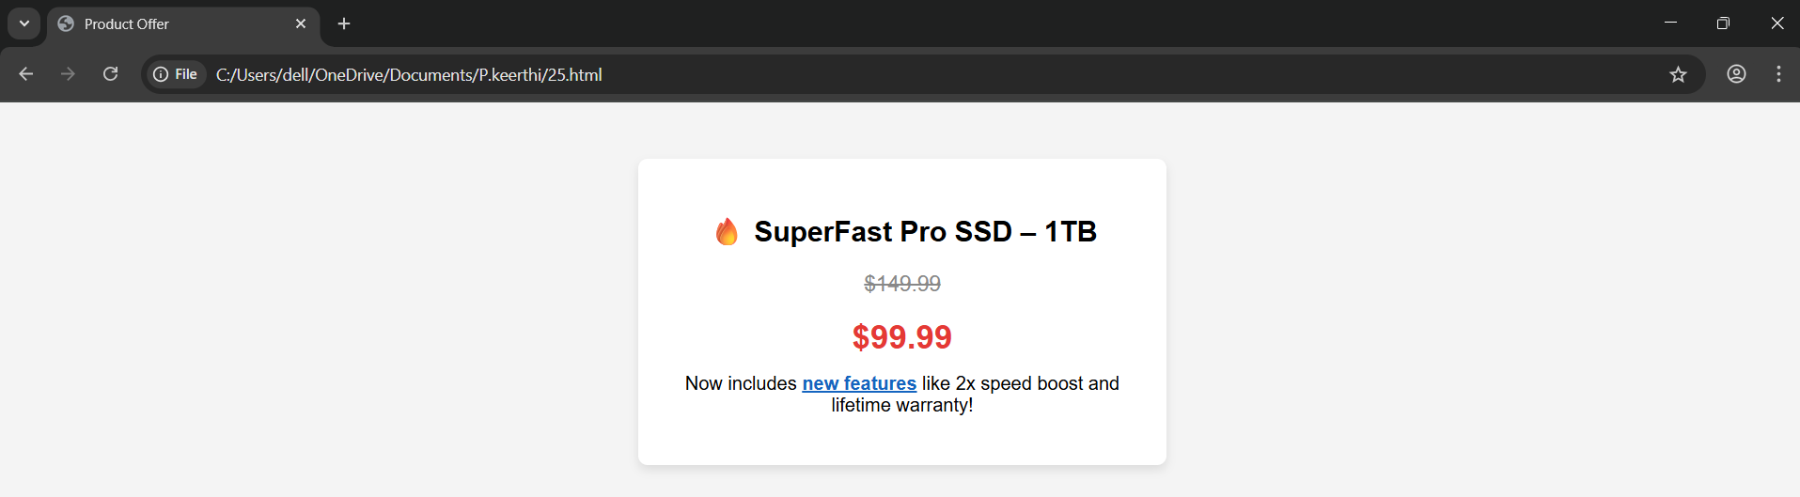

TASK 26:

Design a layout for a blog with:

• A title and navigation menu at the top.

• A main article about a trip you took.

• A sidebar with travel tips

• A footer with your contact email and rights notice.

Code:

<!DOCTYPE html>

<html lang="en">

<head>

  <meta charset="UTF-8">

  <title>Roopa's Travel Blog</title>

  <style>

    body {

      margin: 0;

      font-family: 'Segoe UI', sans-serif;

      background-color: #f9f9f9;

    }

    header {

      background-color: #0066cc;

      color: white;

      padding: 20px;

    }

  header h1 {

      margin: 0;

      font-size: 28px;

    }

    nav {

      margin-top: 10px;

    }

    nav a {

      color: white;

      margin-right: 15px;

      text-decoration: none;

      font-weight: bold;

    }

    .container {

      display: flex;

      padding: 20px;

    }

    .main-article {

      flex: 2;

      padding: 20px;

      background-color: #ffffff;

      margin-right: 20px;

      border-radius: 8px;

      box-shadow: 0 0 8px rgba(0,0,0,0.05);

    }

    .sidebar {

      flex: 1;

      padding: 20px;

      background-color: #eaf4ff;

      border-radius: 8px;

      box-shadow: 0 0 8px rgba(0,0,0,0.05);

    }

    footer {

      background-color: #333;

      color: white;

      text-align: center;

      padding: 15px;

      margin-top: 30px;

    }

    footer a {

      color: #aadfff;

      text-decoration: none;

    }

    h2 {

      color: #0066cc;

    }

    ul {

      padding-left: 20px;

    }

  </style>

</head>

<body>

  <header>

    <h1>Keerthi's Travel Blog</h1>

    <nav>

      <a href="#">Home</a>

      <a href="#">Destinations</a>

      <a href="#">Gallery</a>

      <a href="#">Contact</a>

    </nav>

  </header>

  <div class="container">

    <div class="main-article">

      <h2>My Trip to puri</h2>

      <p>Last month, I visited the beautiful temple in puri. The snow-capped mountains, cool breeze, and the vibrant markets made it a truly memorable experience. I hiked to Solang Valley, enjoyed local cuisine, and met fellow travelers from across the world.</p>

      <p>The sunrise at Rohtang Pass was breathtaking! If you're planning a trip to Arunchalm, Puri should be on your list. It’s peaceful, scenic, and full of adventure opportunities.</p>

    </div>

    <div class="sidebar">

      <h2>Travel Tips</h2>

      <ul>

        <li>Pack light and carry layers</li>

        <li>Keep your documents secure</li>

        <li>Always carry a power bank</li>

        <li>Stay hydrated and eat local food</li>

        <li>Respect local culture and traditions</li>

      </ul>

    </div>

  </div>

  <footer>

    Contact: <a href="mailto:keerthi@example.com">keerthi@example.com</a> | &copy; 2025 keerthi. All rights reserved.

  </footer>

</body>

</html>

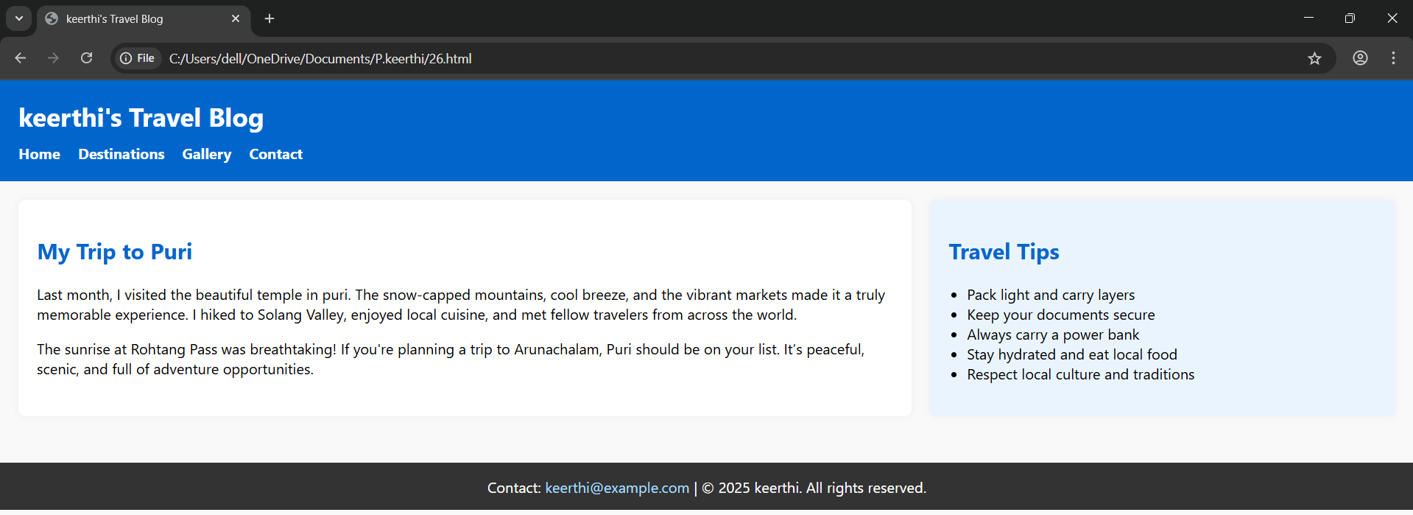

TASK 27:

Simulate a science or math article:

• Mention the chemical formula for water.

• Show the square of a number in proper format.

• Mention a quote from a famous scientist

Code:

<!DOCTYPE html>

<html lang="en">

<head>

  <meta charset="UTF-8">

  <title>Science & Math Insight</title>

  <style>

    body {

      font-family: Georgia, serif;

      background-color: #fdfdfd;

      padding: 40px;

      line-height: 1.7;

      color: #333;

    }

    .article {

      max-width: 700px;

      margin: auto;

      background-color: #fff;

      padding: 25px 30px;

      border: 1px solid #ccc;

      border-radius: 8px;

      box-shadow: 0 0 10px rgba(0,0,0,0.05);

    }

    h1 {

      text-align: center;

      color: #006699

    .quote {

      margin-top: 30px;

      font-style: italic;

      color: #444;

      border-left: 4px solid #007acc;

      padding-left: 15px;

    }

    .quote-author {

      margin-top: 5px;

      text-align: right;

      font-weight: bold;

      color: #222;

    }

  </style>

</head>

<body>

  <div class="article">

    <h1>The Wonders of Science and Math</h1>

    <p>

      One of the most essential compounds for life on Earth is water, which has the chemical formula <strong>H<sub>2</sub>O</strong>.

      This means each molecule contains two hydrogen atoms and one oxygen atom.

    </p>

    <p>

      In mathematics, squaring a number means multiplying it by itself. For example, 5<sup>2</sup> = 25.

      This operation is a key concept in algebra and geometry.

    </p>

    <div class="quote">

      "Imagination is more important than knowledge. For knowledge is limited, whereas imagination embraces the entire world."

      <div class="quote-author">– Albert Einstein</div>

    </div>

  </div>

</body>

</html>

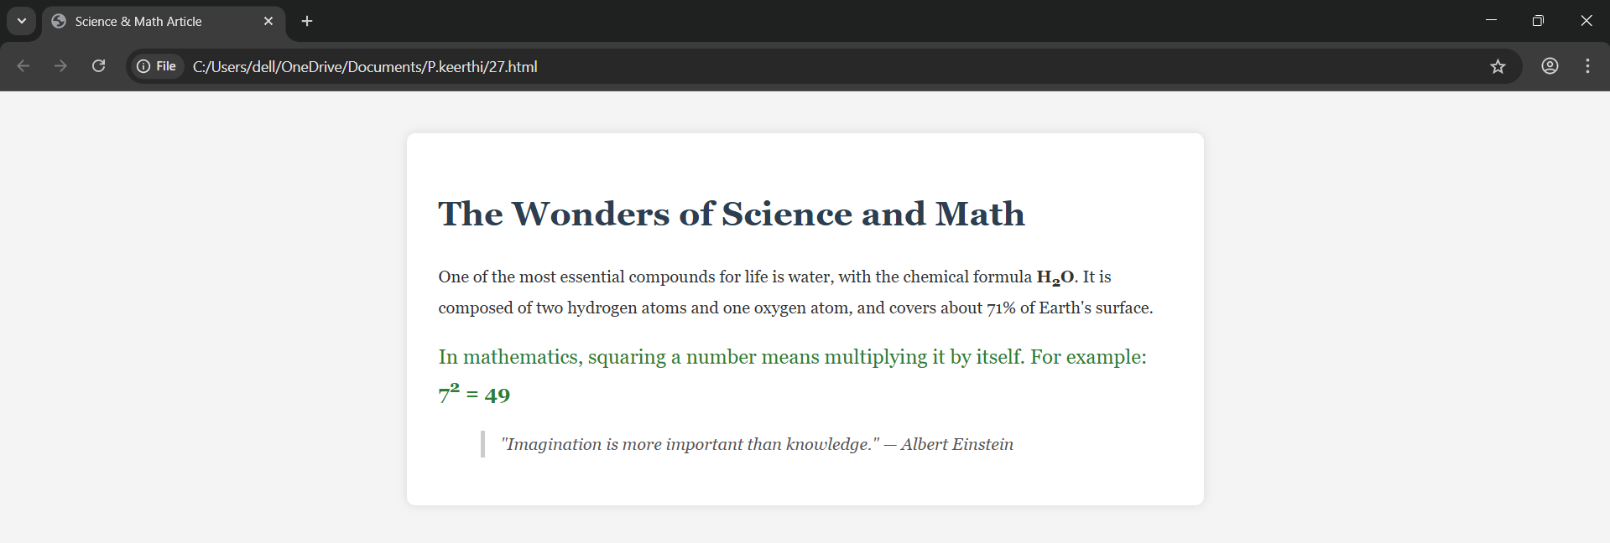

TASK 28:

Create a support form:

• Group address and contact fields inside a boxed section.

• Ask users to enter full name, mobile number, and address.

• Add a heading to this section like “Delivery Info”

Code:

<!DOCTYPE html>

<html lang="en">

<head>

  <meta charset="UTF-8">

  <title>Support Form</title>

  <style>

    body {

      font-family: Arial, sans-serif;

      background-color: #f3f3f3;

      padding: 30px;

    }

    .form-box {

      background-color: #fff;

      border: 2px solid #ccc;

      border-radius: 10px;

      padding: 25px;

      max-width: 500px;

      margin: auto;

      box-shadow: 0 0 10px rgba(0,0,0,0.05);

    }

    h2 {

      margin-top: 0;

      color: #0066cc;

    }

    label {

      display: block;

      margin: 12px 0 6px;

      font-weight: bold;

    }

    input, textarea {

      width: 100%;

      padding: 10px;

      font-size: 15px;

      border: 1px solid #aaa;

      border-radius: 5px;

    }

    textarea {

      resize: vertical;

      min-height: 80px;

    }

    .submit-btn {

      margin-top: 20px;

     background-color: #0066cc;

      color: white;

      padding: 10px 20px;

      font-size: 16px;

      border: none;

      border-radius: 5px;

      cursor: pointer;

    }

    .submit-btn:hover {

      background-color: #004c99;

    }

  </style>

</head>

<body>

  <div class="form-box">

    <h2>Delivery Info</h2>

    <form>

      <label for="fullname">Full Name:</label>

      <input type="text" id="fullname" name="fullname" required>

      <label for="mobile">Mobile Number:</label>

      <input type="tel" id="mobile" name="mobile" required pattern="[0-9]{10}" placeholder="e.g., 9876543210">

      <label for="address">Address:</label>

      <textarea id="address" name="address" required></textarea>

      <button class="submit-btn" type="submit">Submit</button>

    </form>

  </div>

</body>

</html>

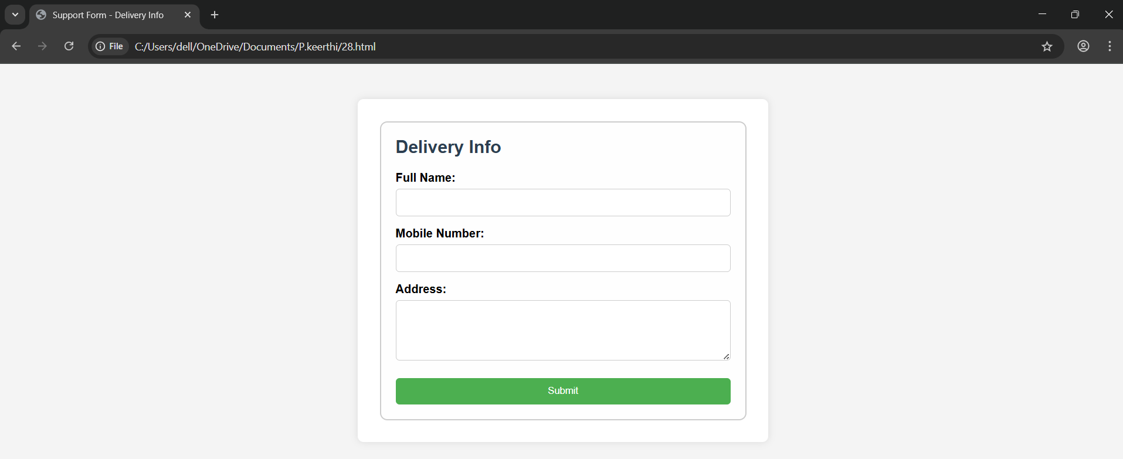

TASK 29:

Develop a mini photo gallery:

• Include one or two images from your favourite place.

• Each image should include a small descriptive caption.

• Arrange the images below a page title.

Code:

<!DOCTYPE html>

<html lang="en">

<head>

  <meta charset="UTF-8">

  <title>My Favorite Place Gallery</title>

  <style>

    body {

      font-family: Arial, sans-serif;

      background-color: #f8f9fa;

      margin: 0;

      padding: 30px;

      text-align: center;

    }

    h1 {

      color: #2c3e50;

      margin-bottom: 30px;

    }

    .gallery {

      display: flex;

      justify-content: center;

      gap: 30px;

      flex-wrap: wrap;

    }

    .photo {

      background-color: #ffffff;

      border: 1px solid #ccc;

      border-radius: 8px;

      padding: 10px;

      box-shadow: 0 0 8px rgba(0,0,0,0.1);

      max-width: 300px;

    }

    .photo img {

      width: 100%;

      border-radius: 6px;

    }

    .caption {

      margin-top: 8px;

      font-size: 14px;

      color: #555;

    }

  </style>

</head>

<body>

  <h1>Gallery: Memories from Puri</h1>

  <div class="gallery">

    <div class="photo">

      <img src=”https://rishikeshdaytour.com/blog/wp-content/uploads/2025/01/jagannath-puri-temple-770x515.jpg”>

      <div class="caption">Early morning view in temple.</div>

    </div>

    <div class="photo">

      <img src=”https://www.chanakyabnrpuri.com/wp-content/uploads/2024/12/Famous-Ancient-Temples-in-Puri.jpg”>

      <div class="caption">Night view in temple.</div>

    </div>

  </div>

</body>

</html>

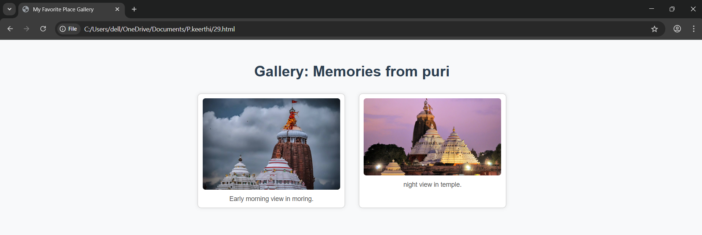

TASK 30:

Create a Layout Using Universal and Type Selectors Instructions:

• Use the universal selector (*) to apply base styles like box-sizing, margin, and padding.

• Apply a common font-family and line-height to all elements.

• Use type selectors (h1, p, ul, etc.) to style headings, paragraphs, and lists.

• Include a header with a title, a content section with paragraphs, and a footer.

Code:

<!DOCTYPE html>

<html lang="en">

<head>

  <meta charset="UTF-8">

  <title>Universal and Type Selector Layout</title>

  <style>

    /* Universal Selector - Base Reset */

    * {

      box-sizing: border-box;

      margin: 0;

      padding: 0;

      font-family: 'Segoe UI', sans-serif;

      line-height: 1.6;

    }

    body {

      background-color: #f4f4f4;

      color: #333;

      padding: 20px;

    }

    header {

      background-color: #0066cc;

      color: white;

      padding: 20px;

      text-align: center;

    }

    h1 {

      font-size: 28px;

    }

    .content {

      background-color: #fff;

      padding: 20px;

      margin: 20px 0;

      border-radius: 8px;

      box-shadow: 0 0 10px rgba(0,0,0,0.05);

    }

    p {

      margin-bottom: 15px;

      font-size: 16px;

    }

    ul {

      list-style-type: disc;

      margin-left: 20px;

      margin-top: 10px;

    }

    footer {

      background-color: #333;

      color: white;

      text-align: center;

      padding: 15px;

      border-radius: 5px;

    }

  </style>

</head>

<body>

  <header>

    <h1>Welcome to My Simple Layout</h1>

  </header>

  <div class="content">

    <p>This is a basic webpage layout that demonstrates the use of the <strong>universal selector (*)</strong> to set base styles for all elements.</p>

    <p>We also use <strong>type selectors</strong> like <code>h1</code>, <code>p</code>, and <code>ul</code> to style specific elements consistently throughout the page.</p>

    <ul>

      <li>Reset margin and padding using *</li>

      <li>Apply global font and line-height</li>

      <li>Style headings, paragraphs, and lists using type selectors</li>

    </ul>

  </div>

  <footer>

    &copy; 2025 keerthi | All rights reserved.

  </footer>

</body>

</html>

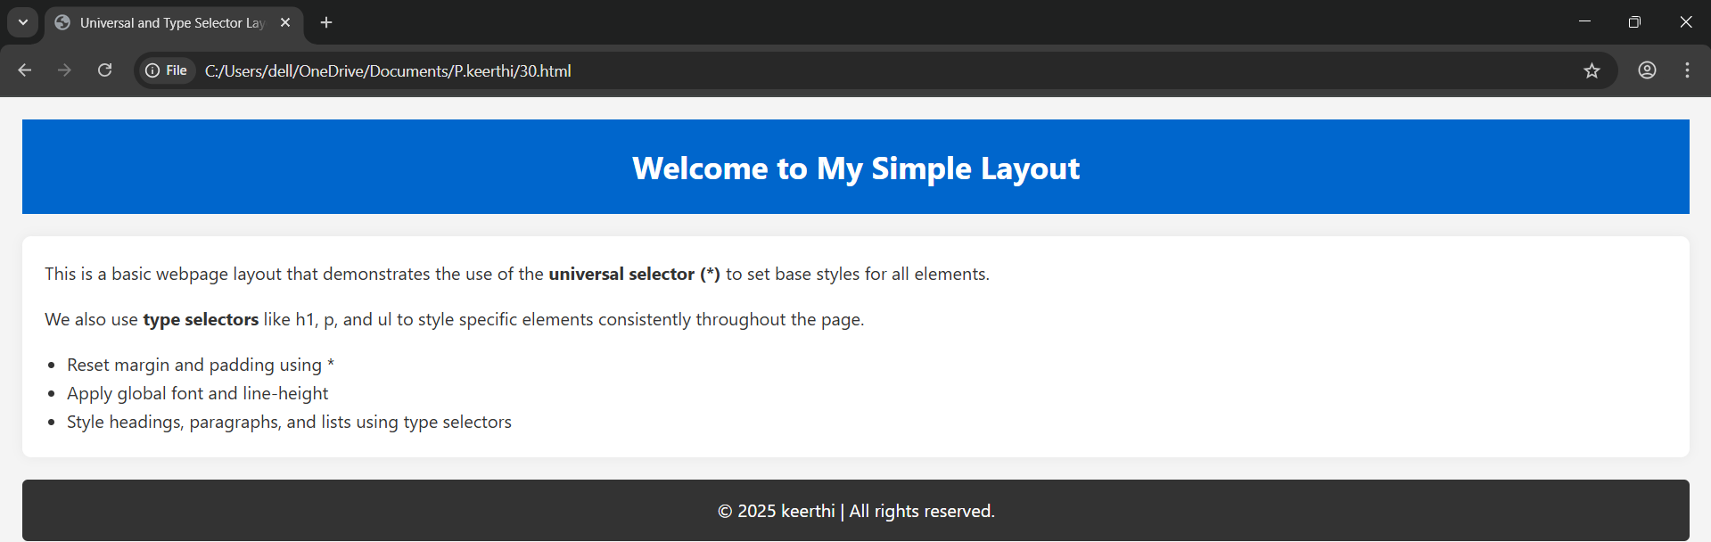

TASK 31:

Create a Login Form Using the and Tags Instructions:

• Create a form with username and password input fields.

• Wrap the form controls inside a

• Add a with the label “Login Details”.

• Style the legend to be bold and slightly larger for emphasis.

Code:

<!DOCTYPE html>

<html lang="en">

<head>

  <meta charset="UTF-8">

  <title>Login Form</title>

  <style>

    body {

      font-family: Arial, sans-serif;

      background-color: #f3f3f3;

      padding: 40px;

    }

    .login-form {

      max-width: 400px;

      margin: auto;

      background-color: #fff;

      padding: 25px;

     border-radius: 10px;

      box-shadow: 0 0 10px rgba(0,0,0,0.1);

    }

    fieldset {

      border: 2px solid #ccc;

      border-radius: 8px;

      padding: 20px;

    }

    legend {

      font-weight: bold;

      font-size: 18px;

      padding: 0 10px;

      color: #0066cc;

    }

    label {

      display: block;

      margin: 15px 0 5px;

    }

    input[type="text"],

    input[type="password"] {

      width: 100%;

      padding: 10px;

      font-size: 15px;

      border: 1px solid #999;

      border-radius: 5px;

    }

    button {

      margin-top: 20px;

      background-color: #0066cc;

      color: white;

      border: none;

      padding: 10px 20px;

      font-size: 16px;

      border-radius: 5px;

      cursor: pointer;

    }

    button:hover {

      background-color: #004a99;

    }

  </style>

</head>

<body>

  <div class="login-form">

    <form>

      <fieldset>

        <legend>Login Details</legend>

        <label for="username">Username:</label>

        <input type="text" id="username" name="username" required>

        <label for="password">Password:</label>

    <input type="password" id="password" name="password" required>

        <button type="submit">Login</button>

      </fieldset>

    </form>

  </div>

</body>

</html>

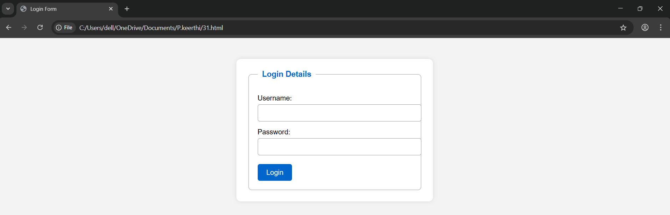

TASK 32:

Style Elements Using Class and ID Selectors Instructions:

• Create a webpage with a title and two or more paragraphs.

• Assign a class (e.g., .highlight) to one or more paragraphs to apply the same style.

• Assign a unique ID (e.g., #main-title) to the heading.

• Use CSS to: o Style the ID with a specific font color and alignment. o Style the class with a background color and padding.

Code:

<!DOCTYPE html>

<html lang="en">

<head>

<meta charset="UTF-8">

<title>Styled Webpage</title>

<style>

/* ID selector for the heading */

#main-title {

color: darkblue;

text-align: center;

}

/* Class selector for paragraphs */

.highlight {

background-color: #f0f8ff;

padding: 10px;

}

</style>

</head>

<body>

<h1 id="main-title">Welcome to My Webpage</h1>

<p class="highlight">

This is the first paragraph. It has a special background color and padding.

</p>

<p>

This is the second paragraph. It is not styled with the class.

</p>

<p class="highlight">

This is another highlighted paragraph with the same styling as the first one.

</p>

</body>

</html>

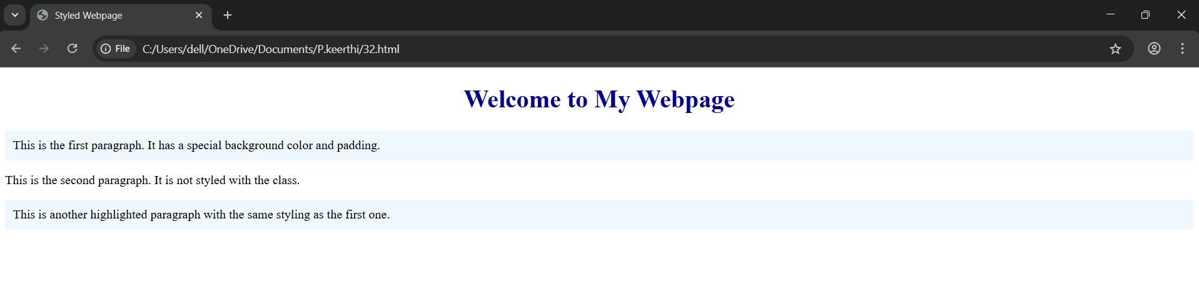

TASK 33:

Design a timetable using css

Code:

<!DOCTYPE html>

<html lang="en">

<head>

<meta charset="UTF-8">

<title>Weekly Timetable</title>

<style>

body {

font-family: Arial, sans-serif;

background-color: #f7f7f7;

padding: 40px;

}

h1 {

text-align: center;

color: #2c3e50;

}

table {

width: 100%;

border-collapse: collapse;

margin-top: 30px;

}

th, td {

border: 1px solid #ccc;

padding: 12px;

text-align: center;

}

th {

background-color: #4CAF50;

color: white;

}

td {

background-color: #fff;

}

tr:nth-child(even) td {

background-color: #f2f2f2;

}

.time-column {

background-color: #e0f7fa;

font-weight: bold;

}

</style>

</head>

<body>

<h1>Weekly Timetable</h1>

<table>

<tr>

<th>Time</th>

<th>Monday</th>

<th>Tuesday</th>

<th>Wednesday</th>

<th>Thursday</th>

<th>Friday</th>

</tr>

<tr>

<td class="time-column">9:00 - 10:00</td>

<td>Math</td>

<td>English</td>

<td>Physics</td>

<td>Biology</td>

<td>Computer</td>

</tr>

<tr>

<td class="time-column">10:00 - 11:00</td>

<td>History</td>

<td>Math</td>

<td>Chemistry</td>

<td>Geography</td>

<td>Art</td>

</tr>

<tr>

<td class="time-column">11:00 - 12:00</td>

<td>Break</td>

<td>Break</td>

<td>Break</td>

<td>Break</td>

<td>Break</td>

</tr>

<tr>

<td class="time-column">12:00 - 1:00</td>

<td>Science</td>

<td>English</td>

<td>Math</td>

<td>Physics</td>

<td>PE</td>

</tr>

</table>

</body>

</html>

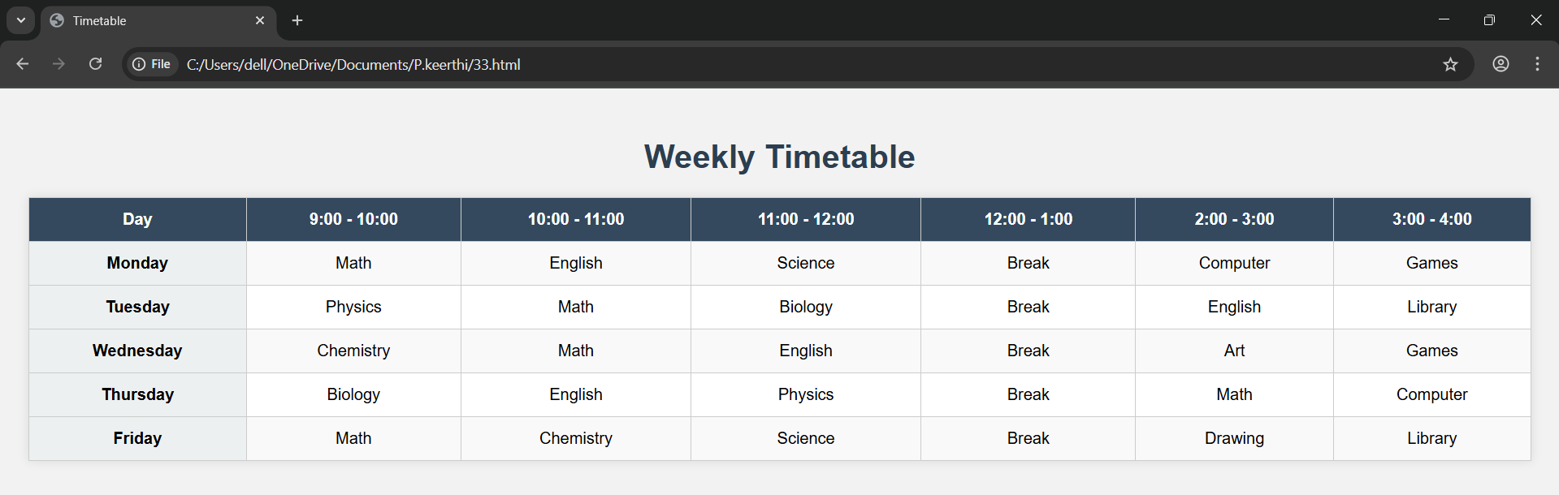

TASK 34:

Create a webpage where you style multiple elements using a class selector.

• Apply the following styles: Set the text color to blue and font size to 18px for all elements that share the same class.

Code:

<!DOCTYPE html>

<html lang="en">

<head>

<meta charset="UTF-8">

<title>Class Selector Styling</title>

<style>

/* Class selector */

.blue-text {

color: blue;

font-size: 18px;

}

</style>

</head>

<body>

<h1 class="blue-text">Welcome to My Webpage</h1>

<p class="blue-text">This paragraph is styled with blue text and 18px font size.</p>

<div class="blue-text">This is a div element that also uses the same class style.</div>

<ul>

<li class="blue-text">List item one</li>

<li class="blue-text">List item two</li>

</ul>

</body>

</html>

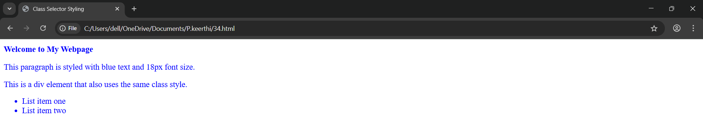

TASK 35:

Define a class selector that changes the background color of the elements to lightgray.

• Additionally, set the font-family to Arial and the padding to 10px.

• Apply this class to at least two elements in the webpage

Code:

<!DOCTYPE html>

<html lang="en">

<head>

<meta charset="UTF-8">

<title>Styled Elements with Class</title>

<style>

/* Class selector */

.custom-style {

background-color: lightgray;

font-family: Arial, sans-serif;

padding: 10px;

}

</style>

</head>

<body>

<h2 class="custom-style">This is a styled heading</h2>

<p class="custom-style">This paragraph uses the same class for background color, font, and padding.</p>

<p>This paragraph does not have the custom style applied.</p>

</body>

</html>

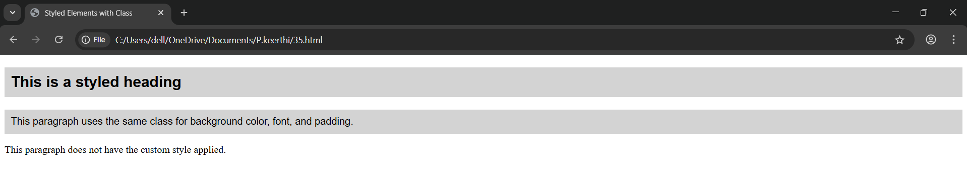

TASK 36:

Use a class selector to style elements with the following properties: o Set the border of the element to 2px solid black. o Change the width to 200px and height to 100px.

• Ensure these styles are applied to elements with this class

Code:

<!DOCTYPE html>

<html lang="en">

<head>

<meta charset="UTF-8">

<title>Box Styling with Class</title>

<style>

/* Class selector */

.box {

border: 2px solid black;

width: 200px;

height: 100px;

padding: 10px;

margin: 10px;

}

</style>

</head>

<body>

<div class="box">Box 1: Styled with class</div>

<div class="box">Box 2: Same style applied</div>

<p>This paragraph is not styled with the box class.</p>

</body>

</html>

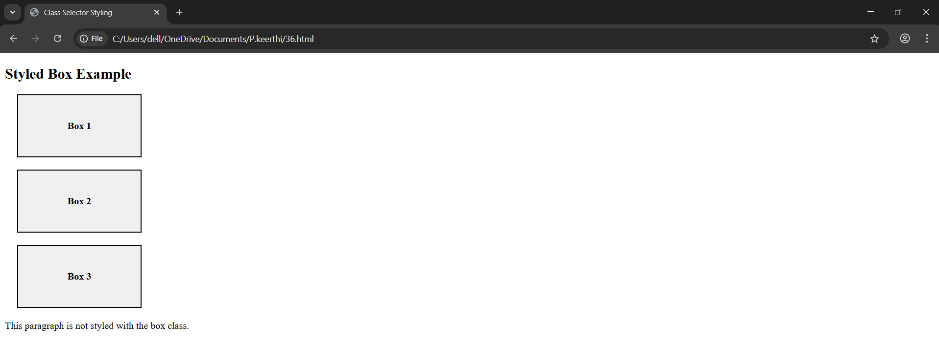

TASK 37:

Welcome Section Design Question: Design a webpage section with a large main title and a brief introduction below it.

• The title should be bold and centered, while the introduction text should be left-aligned with increased line spacing.

• Add a reset to remove any default spacing for the entire page. Selectors to Use: • Type Selector: For the main title (make it bold and center-aligned).

• Type Selector: For the introduction text (left-aligned, line spacing).

• Universal Selector: For resetting default spacing (margin and padding)

Code:

<!DOCTYPE html>

<html lang="en">

<head>

<meta charset="UTF-8">

<title>Welcome Section</title>

<style>

/* Universal Selector - reset default spacing */

* {

margin: 0;

padding: 0;

box-sizing: border-box;

}

/* Type selector for the main title */

h1 {

text-align: center;

font-weight: bold;

font-size: 36px;

margin-top: 40px;

}

/* Type selector for the introduction paragraph */

p {

text-align: left;

line-height: 1.8;

font-size: 18px;

padding: 20px 40px;

}

</style>

</head>

<body>

<h1>Welcome to Our Website</h1>

<p>

This website offers a wide range of resources and tools to help you learn web development.

Our goal is to make learning simple, accessible, and effective. Explore the sections below to get started!

</p>

</body>

</html>

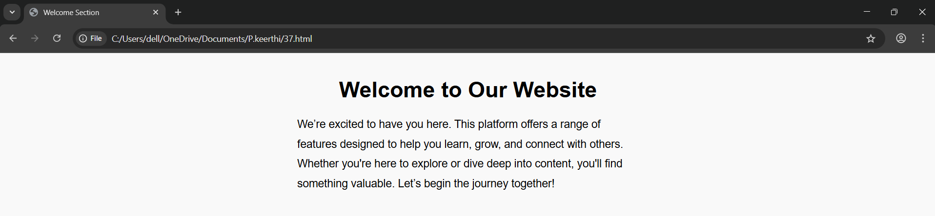

TASK 38:

Product Showcase Question: Create a card showcasing a product with an image, a product name, a brief description, and a clickable button for purchase.

• The product name should be large and bold, while the description should be in smaller text with a light background color.

• The button should have a hover effect, changing its background color. Selectors to Use:

• Type Selector: For the product name (large and bold).

• Type Selector: For the description (smaller text with light background).

• Class Selector: For the purchase button (hover effect with background change).

• Universal Selector: For consistent font style and box-sizing.

Code:

<!DOCTYPE html>

<html lang="en">

<head>

<meta charset="UTF-8">

<title>Product Showcase</title>

<style>

/* Universal selector for consistent font and box-sizing */

* {

box-sizing: border-box;

font-family: Arial, sans-serif;

margin: 0;

padding: 0;

}

body {

background-color: #f2f2f2;

padding: 40px;

display: flex;

justify-content: center;

}

.product-card {

width: 300px;

background-color: #fff;

border: 1px solid #ddd;

border-radius: 10px;

overflow: hidden;

box-shadow: 0 2px 10px rgba(0, 0, 0, 0.1);

}

img {

width: 100%;

height: auto;

}

h2 {

font-size: 24px;

font-weight: bold;

text-align: center;

margin: 15px 0;

}

p {

font-size: 14px;

background-color: #f9f9f9;

padding: 15px;

text-align: center;

line-height: 1.5;

}

.buy-button {

display: block;

width: 80%;

margin: 15px auto 20px;

padding: 10px;

background-color: #007bff;

color: white;

text-align: center;

border: none;

border-radius: 5px;

cursor: pointer;

transition: background-color 0.3s ease;

text-decoration: none;

}

.buy-button:hover {

background-color: #0056b3;

}

</style>

</head>

<body>

<div class="product-card">

<img src="

<h2>Smart watch</h2>

<p>Experience high-quality sound with noise cancellation and up to 20 hours of battery life. Perfect for work and travel.</p>

<a href="#" class="buy-button">Buy Now</a>

</div>

</body>

</html>

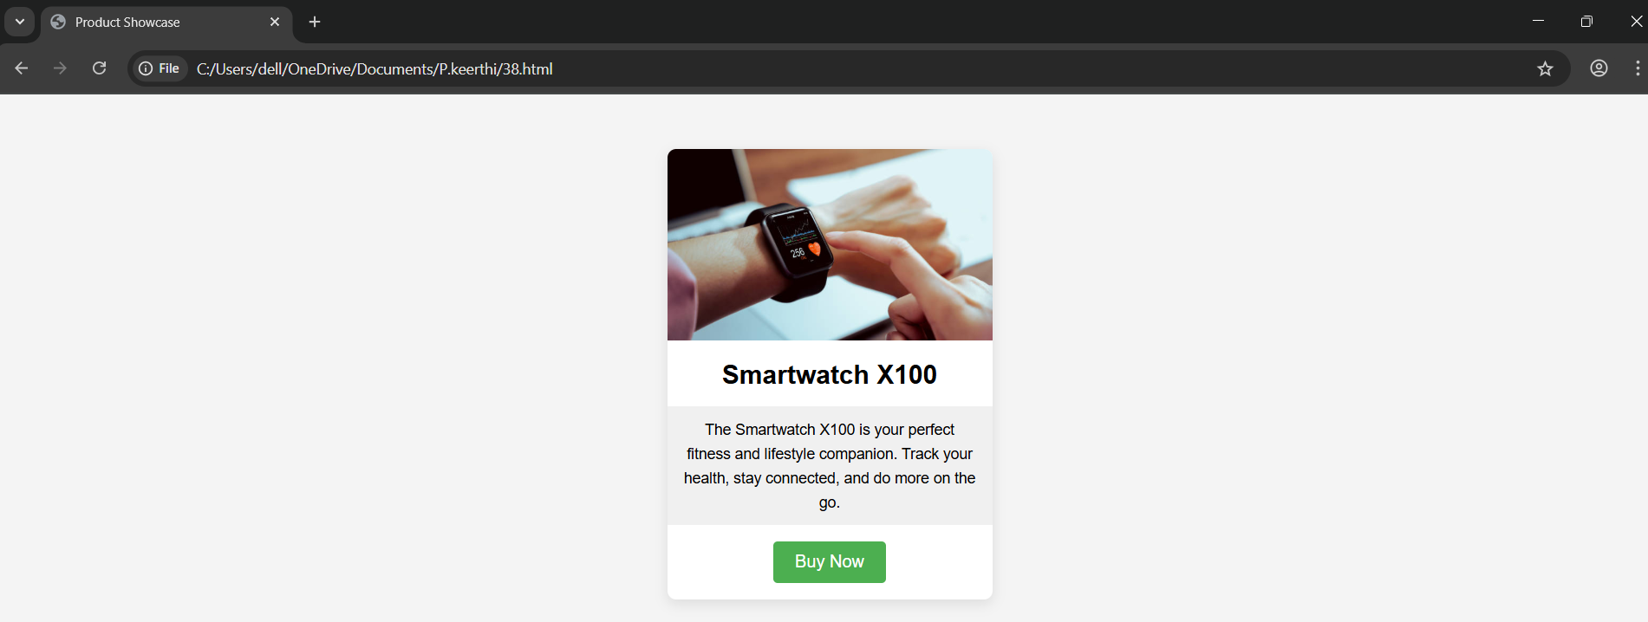

TASK 39:

Navigation Bar Question: Build a horizontal navigation bar with multiple clickable menu options.

• Each option should change color when hovered.

• One of the options should appear highlighted as the active option. Selectors to Use:

• Type Selector: For the menu options (basic styling).

• Class Selector: For the active menu option (highlighted). Class Selector: For hover effect on menu options (color change).

• Universal Selector: For removing default margin and padding of the navbar.

Code:

<!DOCTYPE html>

<html lang="en">

<head>

<meta charset="UTF-8">

<title>Navigation Bar</title>

<style>

/* Universal Selector - remove default spacing */

* {

margin: 0;

padding: 0;

box-sizing: border-box;

}

/* Navigation bar container */

nav {

background-color: #333;

padding: 10px 0;

}

/* Type Selector for menu options (links) */

nav a {

color: white;

text-decoration: none;

padding: 14px 20px;

display: inline-block;

font-size: 16px;

}

/* Class Selector for active menu option */

.active {

background-color: #007bff;

font-weight: bold;

}

/* Class Selector for hover effect */

nav a:hover {

background-color: #555;

}

</style>

</head>

<body>

<nav>

<a href="#" class="active">Home</a>

<a href="#">About</a>

<a href="#">Services</a>

<a href="#">Products</a>

<a href="#">Contact</a>

</nav>

</body>

</html>

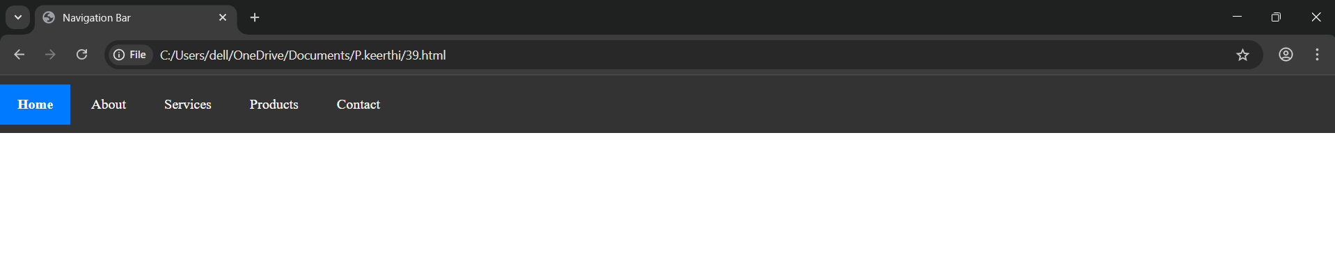

TASK 40:

User Profile Card Question: Design a card featuring a user’s profile picture, name, and a short bio.

• The name should appear prominently, and the bio should be in a smaller font.

• Add a button below the bio that changes color when hovered. Selectors to Use: • Type Selector: For the profile name (large font) and bio (smaller font).

• Class Selector: For the button (hover effect with background change).

• Universal Selector: For consistent padding and font style.

Code:

<!DOCTYPE html>

<html lang="en">

<head>

<meta charset="UTF-8">

<title>User Profile Card</title>

<style>

/* Universal Selector for consistency */

* {

box-sizing: border-box;

font-family: Arial, sans-serif;

padding: 0;

margin: 0;

}

body {

background-color: #f4f4f4;

display: flex;

justify-content: center;

align-items: center;

height: 100vh;

}

.profile-card {

background-color: #fff;

width: 300px;

padding: 20px;

border-radius: 10px;

text-align: center;

box-shadow: 0 4px 10px rgba(0, 0, 0, 0.1);

}

img {

width: 100px;

height: 100px;

border-radius: 50%;

margin-bottom: 15px;

}

/* Type Selector for Name */

h2 {

font-size: 24px;

font-weight: bold;

margin-bottom: 10px;

}

/* Type Selector for Bio */

p {

font-size: 14px;

color: #555;

margin-bottom: 20px;

}

/* Class Selector for Button */

.follow-btn {

background-color: #007bff;

color: white;

padding: 10px 20px;

border: none;

border-radius: 5px;

cursor: pointer;

transition: background-color 0.3s ease;

}

.follow-btn:hover {

background-color: #0056b3;

}

</style>

</head>

<body>

<div class="profile-card">

<img src=" https://encrypted-tbn0.gstatic.com/images?q=tbn:ANd9GcSHN2j_wLE5GYM9TrFzbZsxwHylNr29yAMmq_X_qLzX9zpNwUcNwWfGPHtbgshrKU0VDSc&usqp=CAU

" alt="User Picture">

<h2>Monika</h2>

<p>Web developer with a passion for creating user-friendly interfaces and interactive web apps.</p>

<button class="follow-btn">Follow</button>

</div>

</body>

</html>

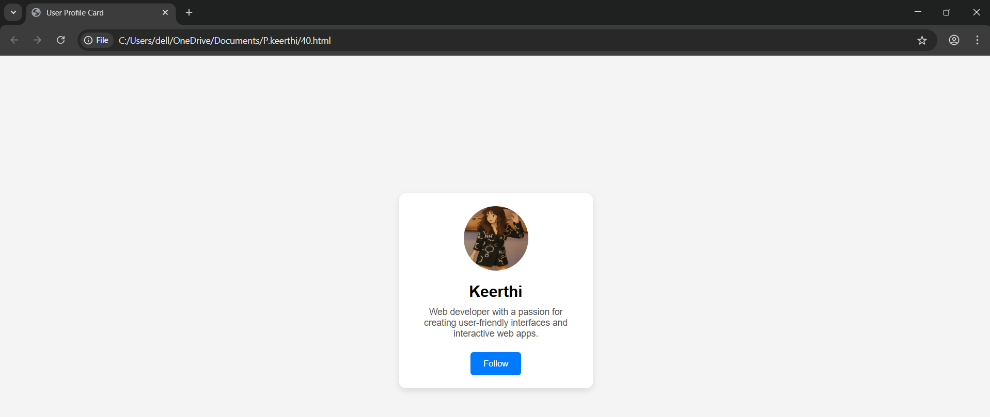

TASK 41:

Blog Layout Question: Design a blog layout with a main title, multiple blog posts with a title and description, and a side section for additional information.

• The main title should be large and centered.

• The blog posts should appear stacked vertically, each with a bold title and normal text below.

• The side section should be styled separately with a different background color. Selectors to Use:

• Type Selector: For the main title (large and centered).

• Type Selector: For the blog post titles and descriptions (bold for titles).

• Class Selector: For the sidebar (different background color).

• Universal Selector: For consistent font and layout.

Code:

<!DOCTYPE html>

<html lang="en">

<head>

<meta charset="UTF-8">

<title>My Blog</title>

<style>

/* Universal Selector for consistent font and layout */

* {

box-sizing: border-box;

font-family: Arial, sans-serif;

margin: 0;

padding: 0;

}

body {

display: flex;

padding: 20px;

background-color: #f0f0f0;

}

/* Sidebar styling using class selector */

.sidebar {

width: 25%;

background-color: #e0e0e0;

padding: 20px;

margin-right: 20px;

border-radius: 8px;

}

/* Blog section */

.blog {

width: 75%;

}

/* Type selector for main blog title */

h1 {

text-align: center;

font-size: 36px;

margin-bottom: 30px;

}

/* Blog post styling */

article {

background-color: #fff;

padding: 20px;

margin-bottom: 20px;

border-radius: 8px;

box-shadow: 0 2px 8px rgba(0,0,0,0.05);

}

/* Type selector for blog post titles */

h2 {

font-size: 22px;

font-weight: bold;

margin-bottom: 10px;

}

/* Type selector for descriptions */

p {

font-size: 16px;

line-height: 1.6;

color: #333;

}

</style>

</head>

<body>

<!-- Sidebar -->

<div class="sidebar">

<h3>About Me</h3>

<p>I’m a passionate blogger sharing thoughts on technology, design, and life.</p>

<h3>Categories</h3>

<ul>

<li>Tech</li>

<li>Design</li>

<li>Lifestyle</li>

</ul>

</div>

<!-- Blog Main Content -->

<div class="blog">

<h1>Welcome to My Blog</h1>

<article>

<h2>How to Learn Web Development</h2>

<p>Start with HTML, CSS, and JavaScript. Practice daily and build real-world projects to gain experience.</p>

</article>

<article>

<h2>Design Tips for Beginners</h2>

<p>Focus on simplicity, whitespace, and readability. Use color and typography to guide the user's eye.</p>

</article>

<article>

<h2>Staying Productive While Working from Home</h2>

<p>Maintain a routine, set boundaries, and make time for breaks to stay productive and mentally fresh.</p>

</article>

</div>

</body>

</html>

